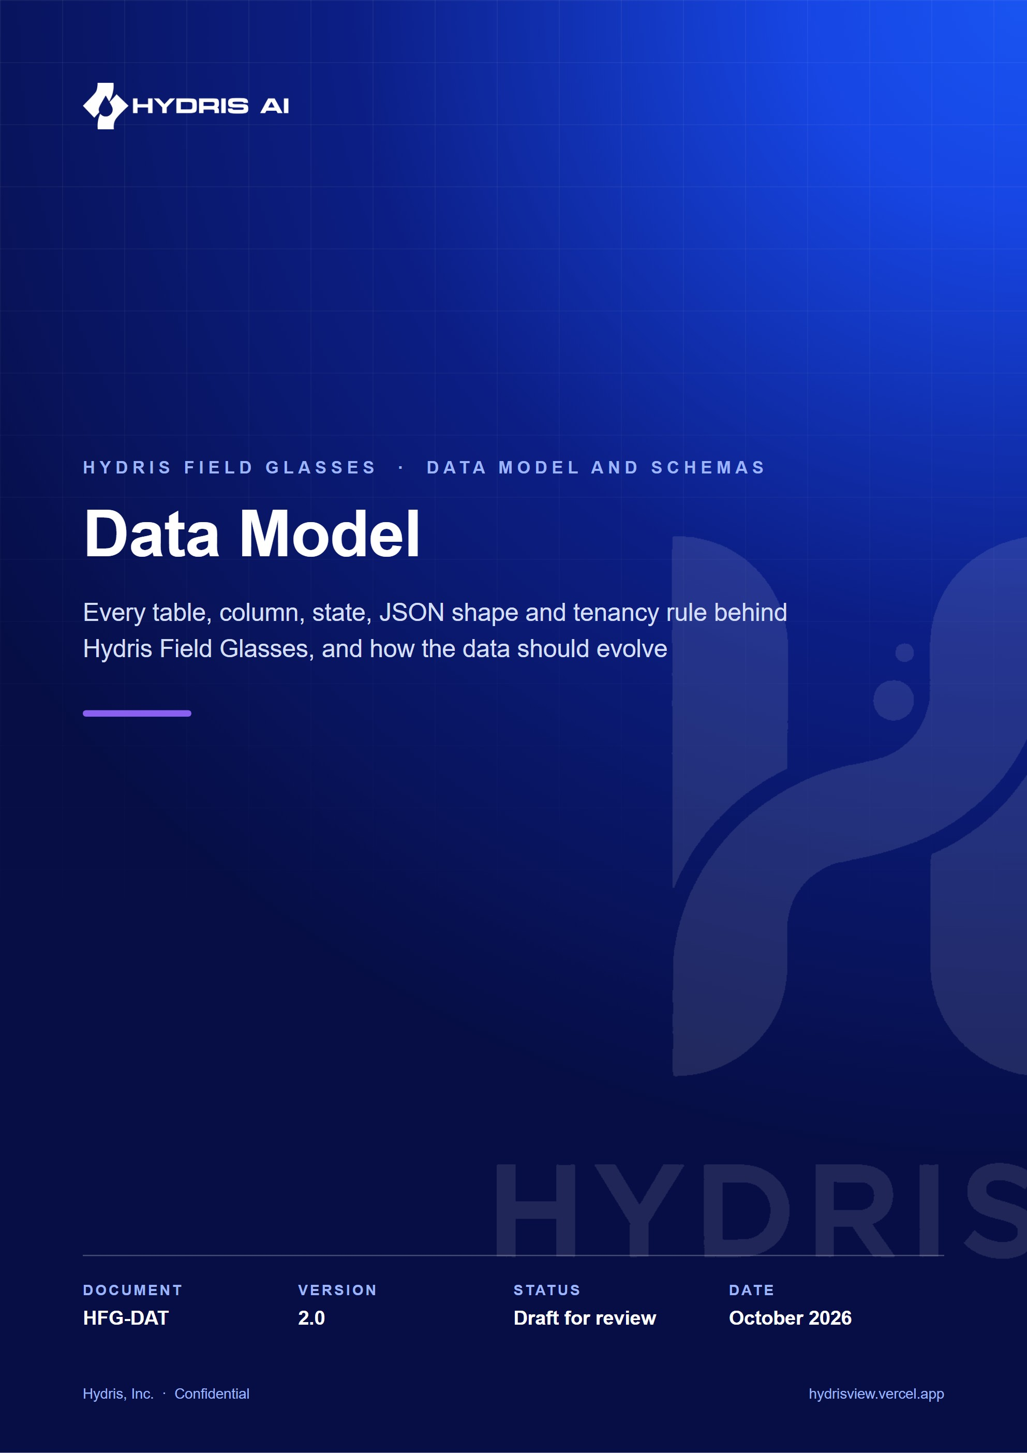
Document control
Document | Data Model (HFG-DAT)
Version | 2.0
Status | Draft for review
Owner | Engineering, Hydris
Audience | Backend and mobile engineering, data and analytics, security reviewers, solution architects
Product | Hydris Field Glasses: website, operator console, glasses app, Android app, API
Source of truth | docs/product/DATA_MODEL.md in tarun-km/hydrisview (this Word file is generated from it)
Classification | Confidential: Hydris, Inc. and named partners
Revision history
Version | Date | Author | Changes
2.0 | October 2026 | Engineering, Hydris | Expanded edition with per-domain ER diagrams, a full data dictionary, JSON schemas, state models, RLS, lifecycle, volumes and privacy classification

Contents
1 Data principles 6
2 Domain overview 8
2.1 Conventions 9
3 Entity relationship model 10
3.1 Identity and tenancy 10
3.2 Plant model 11
3.3 Telemetry 13
3.4 Alarms and procedures 14
3.5 Inspections and maintenance 15
3.6 Devices and UI profiles 16
3.7 Audit documents 17
3.8 Platform and demo storage 18
4 Data dictionary 19
4.1 Identity and tenancy tables 19
4.2 Plant model tables 23
4.3 Telemetry tables 25
4.4 Alarm and procedure tables 28
4.5 Work tables 31
4.6 Device and UI profile tables 35
4.7 Audit document tables 39
4.8 Platform tables 41
5 Enumerations 45
5.1 Postgres enum types 45
5.2 Text-typed value sets 46
6 JSON column schemas 48
6.1 Inspection steps and step values 48
6.2 Maintenance checklist 48
6.3 Audit extraction 48
6.4 OCR readings per page 49
6.5 UI profile configuration 50
6.6 Smaller JSON columns 50
7 State models 52
7.1 Alarm events 52
7.2 Inspections 54
7.3 Maintenance tasks 55
7.4 Audit documents 56
7.5 Pairing challenges and devices 57
8 Tenancy and row-level security 58
8.1 How organization context is set 58
8.2 Policy inventory 60
8.3 Checklist for a new tenant table 60
8.4 Site scoping 61
9 Module access patterns 62
10 Indexing and query patterns 64
11 Data quality rules 65
11.1 Telemetry ingestion 65
11.2 Freshness 66
11.3 Corrections 66
11.4 Inspections 66
11.5 Audit documents 66
12 Data lifecycle and retention 68
12.1 Current behaviour 68
12.2 Recommended policy 68
13 Volumes and growth 70
13.1 Telemetry 70
13.2 Other tables 71
13.3 Demo tenant 71
14 Binary and image storage 72
14.1 Proposed migration to object storage 72
15 Migrations 74
15.1 Process 74
15.2 Rules for schema changes 74
16 Seed and demo data 75
17 Privacy classification 76
18 Mobile and client-side data 78
18.1 Android app 78
18.2 Web glasses app 78
19 Analytics and event model 79
19.1 Principles 79
19.2 Proposed event schema 79
20 Future schema changes 81
21 Open questions and unverified facts 82

This document describes the persistent data of Hydris Field Glasses: what is stored, where, in which shape, who may read it, how long it lives and how it is expected to grow. It is written for engineers who change the schema, for data and analytics people who query it, and for security reviewers who need to know which tables hold personal or sensitive data.
Everything about the current product is taken from the code on main:
- Schema: apps/api/src/db/schema.ts (Drizzle ORM, one file, 42 tables).
- Migrations: apps/api/drizzle/0000_init.sql to 0008_audit_documents_rls.sql, with snapshots in apps/api/drizzle/meta/.
- Tenancy helpers: apps/api/src/db/tenant.ts and apps/api/src/context.ts.
- Shared types and enumerations: packages/domain/src/* (catalog.ts, alarms.ts, workflows.ts, devices.ts, measurands.ts, uiprofile.ts, auditdoc.ts, roles.ts).
- Seed and demo data: apps/api/src/seed/demo.ts, apps/api/src/seed/showcase.ts, apps/api/src/core/demo-shared.ts.
- Client-side storage: apps/android/app/src/main/java/ai/hydris/field/data/SecureStore.kt and apps/web/src/glasses/link.ts.
Statements are marked Built (on main), Partial or Planned. Volume and storage figures are estimates and are labelled as such.
42  Tables in the Drizzle schema  plus 1 runtime table in demo mode |  | 548  Columns  from the 0008 snapshot |  | 23  Postgres enum types  22 in 0000, 1 in 0007 |  | 9  SQL migrations  0000 to 0008

71  Indexes  23 unique, 4 of them partial |  | 130  Foreign keys  cascade from organizations |  | 36  Tables with row-level security  6 system-only tables without |  | 23  JSONB columns  typed in TypeScript, not in SQL

1 Data principles
The schema follows a small set of rules. New tables and columns are expected to follow them too; a review that breaks one should say why.
Table 1. Data principles and where the code enforces them
# | Principle | How it shows up in the code
P1 | Every tenant row carries org_id. Tenancy is a column, not a database or schema per customer. | orgRef() helper in schema.ts adds org_id uuid not null references organizations(id) on delete cascade to every tenant table.
P2 | Isolation is enforced by the database, not only by queries. A missing WHERE org_id = ... must not leak data. | Row-level security policy tenant_isolation on 35 tables; requests run as the non-privileged role hydris_app (0001_rls.sql, tenant.ts).
P3 | Provenance is explicit. Every measurement says where it came from and whether it is synthetic. | telemetry_readings.source, quality, synthetic plus CHECK telemetry_synthetic_source_ck; synthetic flags on alarms, inspections and maintenance tasks.
P4 | History is appended, never overwritten. Corrections, reviews and decisions add rows. | telemetry_corrections, alarm_event_history, maintenance_activity, audit_document_events, audit_events (UPDATE and DELETE revoked on three of them).
P5 | Missing data is not zero. A value without a timestamp is meaningless. | sensors.last_value and last_ts are nullable; freshness() in packages/domain/src/freshness.ts returns no_data instead of 0.
P6 | One canonical unit per measurand. Conversion happens at ingestion. | normalizeMeasurement() in measurands.ts; sensors.unit stores the canonical unit.
P7 | Snapshots protect history from later edits. | inspections.steps copies the template steps at assignment time; AuditField.extracted keeps the first extracted value.
P8 | Offline clients replay safely. | Unique (inspection_id, client_op_id) on inspection_responses; unique (sensor_id, ts) on telemetry_readings; revision counters for optimistic locking.
P9 | Secrets are stored as hashes or ciphertext. | password_hash (argon2id), token_hash, key_hash, code_hash, poll_secret_hash (SHA-256), mfa_secret_enc (AES-256-GCM with DATA_KEY).
P10 | Times are UTC timestamptz. Site and organization time zones are display settings. | ts() helper uses timestamp with time zone; sites.timezone and organizations.timezone default to UTC.

DECISION
Shared-schema multi-tenancy with RLS was chosen over a database per tenant. It keeps one migration path, one connection pool and cheap tenant creation, and moves the isolation guarantee into Postgres. The cost is that every new tenant table must be added to an RLS migration; section "Tenancy and row-level security" lists the checklist.

2 Domain overview
The 42 tables fall into ten domains. Each domain is owned by one API module in apps/api/src/modules/.
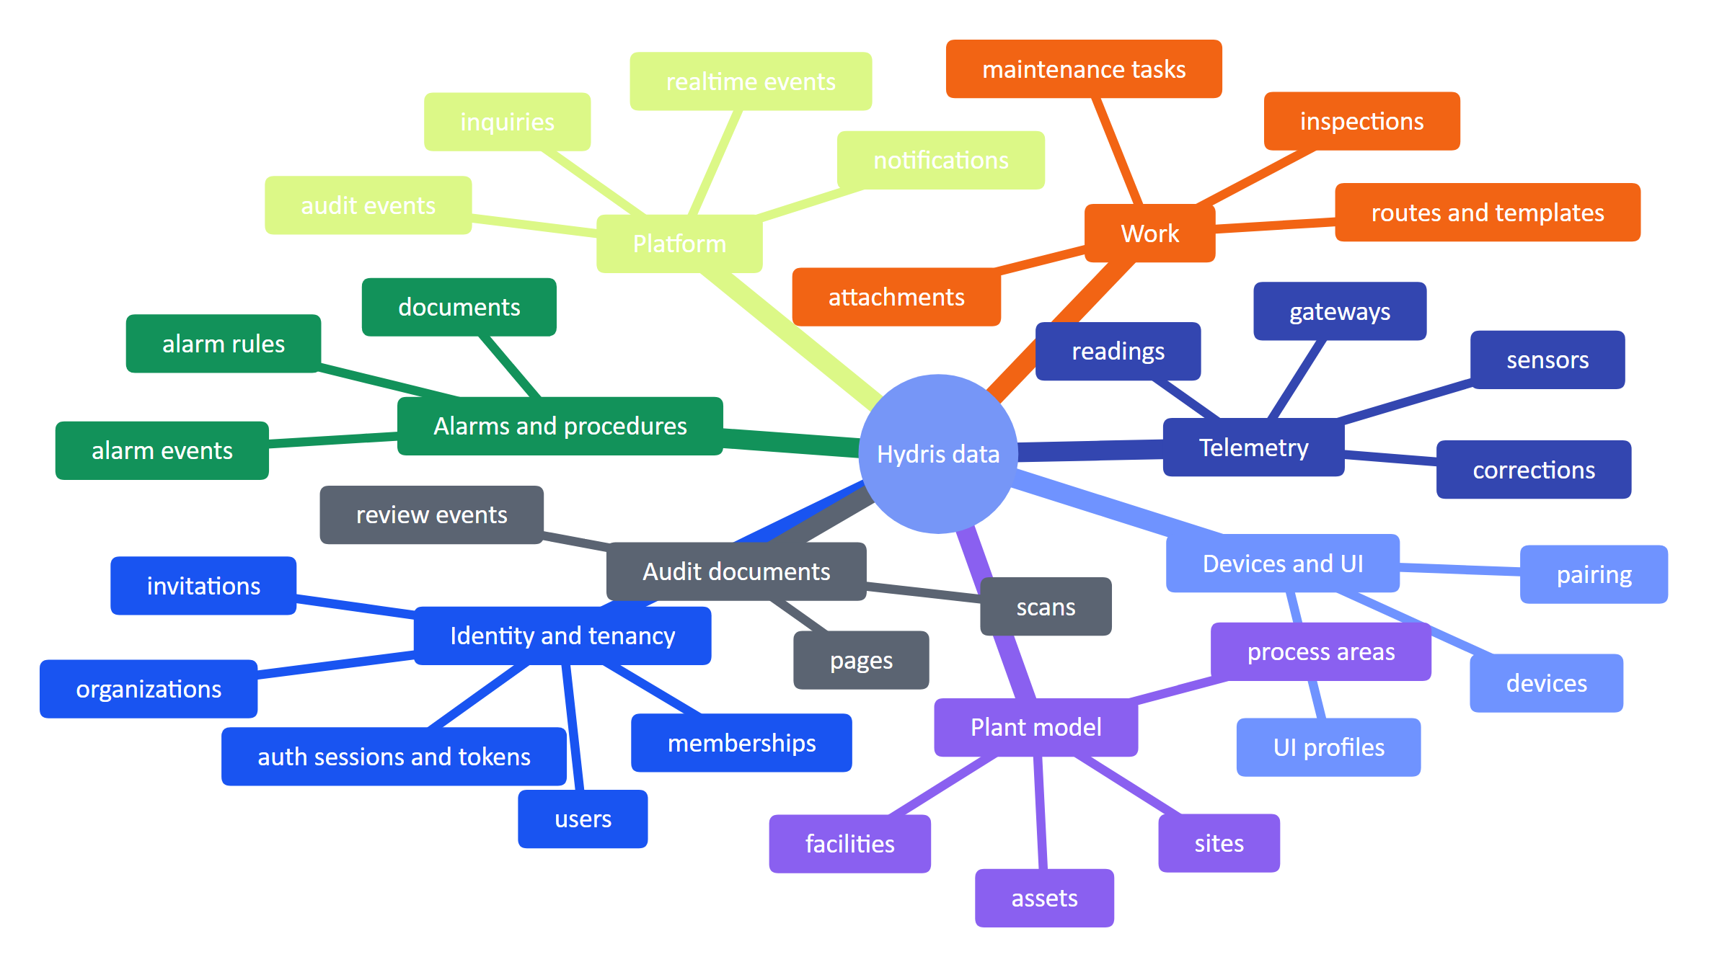
Figure 1. Data domains of Hydris Field Glasses and their main tables
Table 2. Domains, tables and owning modules
Domain | Tables | Owning module(s) | Status
Identity and tenancy | users, organizations, memberships, membership_sites, invitations, auth_sessions, auth_tokens, mail_outbox | auth.ts, org.ts | Built
Plant model | sites, facilities, process_areas, assets | plant.ts | Built
Telemetry | gateways, sensors, telemetry_readings, telemetry_corrections | telemetry.ts, plant.ts | Built
Alarms and procedures | alarm_rules, alarm_events, alarm_event_history, documents | alarms.ts, plant.ts, insights.ts | Built
Work | inspection_templates, inspection_routes, inspections, inspection_responses, maintenance_tasks, maintenance_activity, attachments | inspections.ts, maintenance.ts, plant.ts | Built
Devices and UI profiles | devices, device_assignments, pairing_challenges, device_sessions, ui_profiles, ui_profile_versions, ui_profile_assignments | devices.ts, ui-profiles.ts | Built
Audit documents | audit_documents, audit_document_pages, audit_document_events | audit-docs.ts | Built
Platform | audit_events, notifications, realtime_events, inquiries, simulation_runs | core/services.ts, core/events.ts, public.ts, simulation.ts | Built
Demo key/value | hydris_demo_kv (created at runtime, not in migrations) | core/demo-shared.ts | Built (demo mode only)

2.1 Conventions
- Primary keys are uuid with DEFAULT gen_random_uuid() (helper pk()), except the two high-volume append logs telemetry_readings and realtime_events, which use bigint GENERATED ALWAYS AS IDENTITY, and membership_sites, which has a composite key.
- Timestamps: created_at and updated_at are timestamptz not null default now(). updated_at is set by the application on every update (there are no triggers).
- Soft delete: plant objects and UI profiles use archived_at. Hard deletes are rare and guarded (an asset with sensors, alarms, inspections or tasks returns in_use; an alarm rule with events is disabled instead of deleted).
- Text-typed states: some small state sets are text columns typed with $type<...>() in TypeScript rather than Postgres enums (for example users.status, devices.kind, audit_documents.ai_status). Section "Enumerations" lists both kinds.
- Naming: tables are plural snake case; foreign keys are <entity>_id; actor columns are <verb>_by (user) and <verb>_at (time).

3 Entity relationship model
The full model is too large for one readable diagram, so it is split by domain. Shared entities (organizations, users, sites, assets, devices) appear as stubs with only their key where they are referenced from another domain. Every tenant table also has org_id referencing organizations.id with ON DELETE CASCADE; that edge is drawn only in the identity diagram to keep the others legible. Column types use Postgres names (timestamptz, float8 for double precision).

3.1 Identity and tenancy
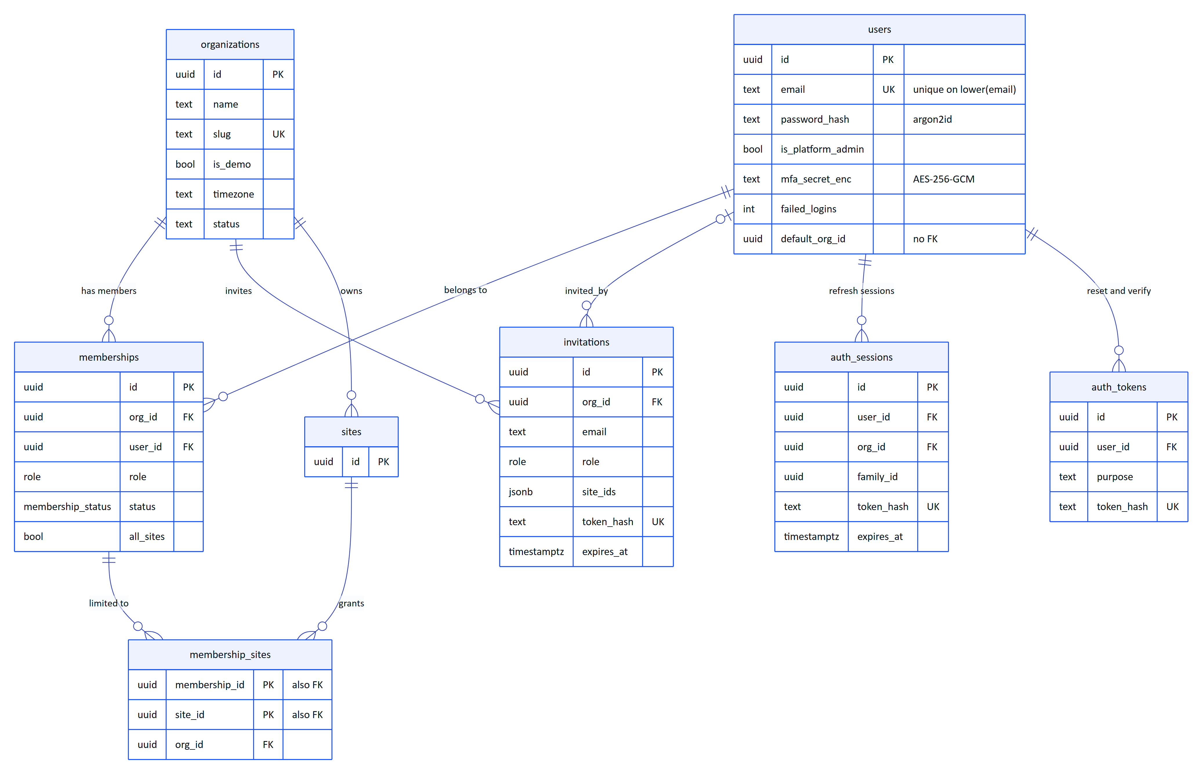
Figure 2. Identity and tenancy: users join organizations through memberships, optionally limited to sites
users is global: one person can belong to several organizations with a different role in each. The active organization is carried in the access token (org claim) and resolved to a membership on every request. mail_outbox stands alone (no foreign keys) and is not drawn.

3.2 Plant model
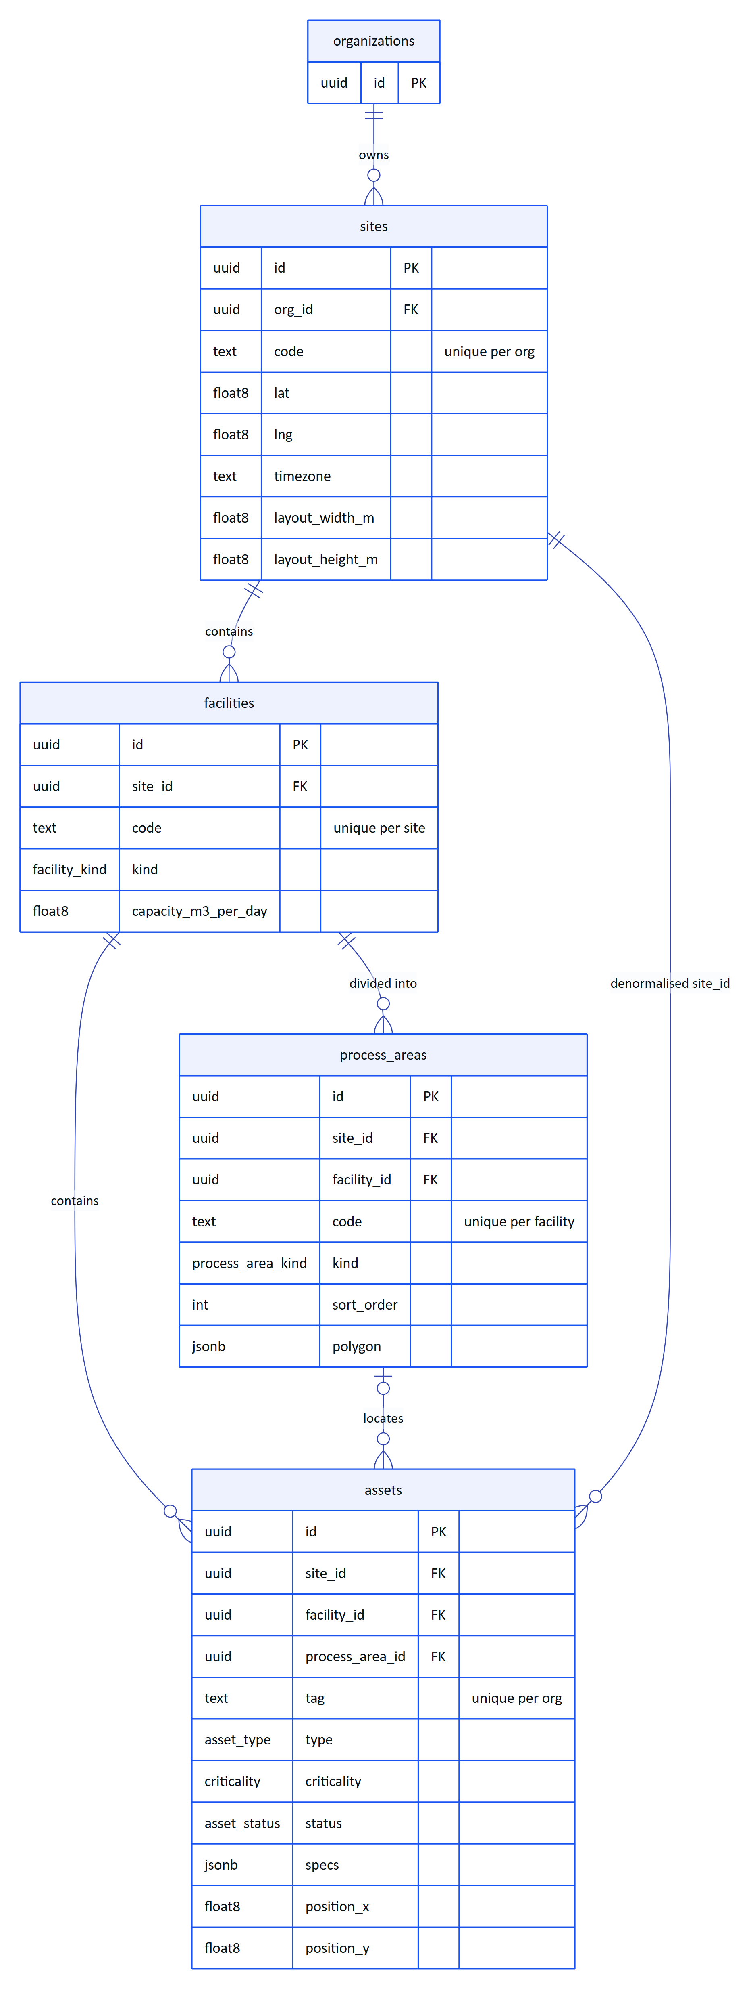
Figure 3. Plant model: site, facility, process area and asset hierarchy
assets.site_id duplicates what can be derived through facility_id; it is kept so that site-scoped queries and site permission checks need no join.

3.3 Telemetry
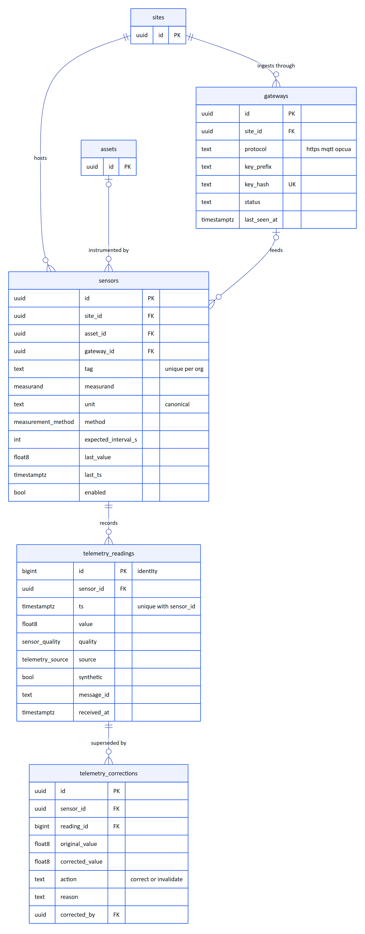
Figure 4. Telemetry: gateways feed sensors, sensors record readings, corrections supersede readings

3.4 Alarms and procedures
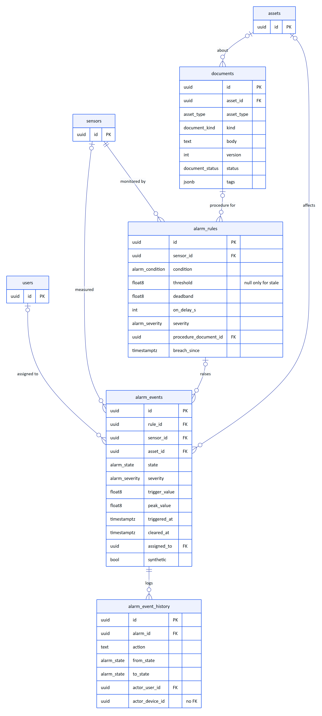
Figure 5. Alarms and procedures: rules watch sensors, events carry the human lifecycle, documents hold SOPs

3.5 Inspections and maintenance
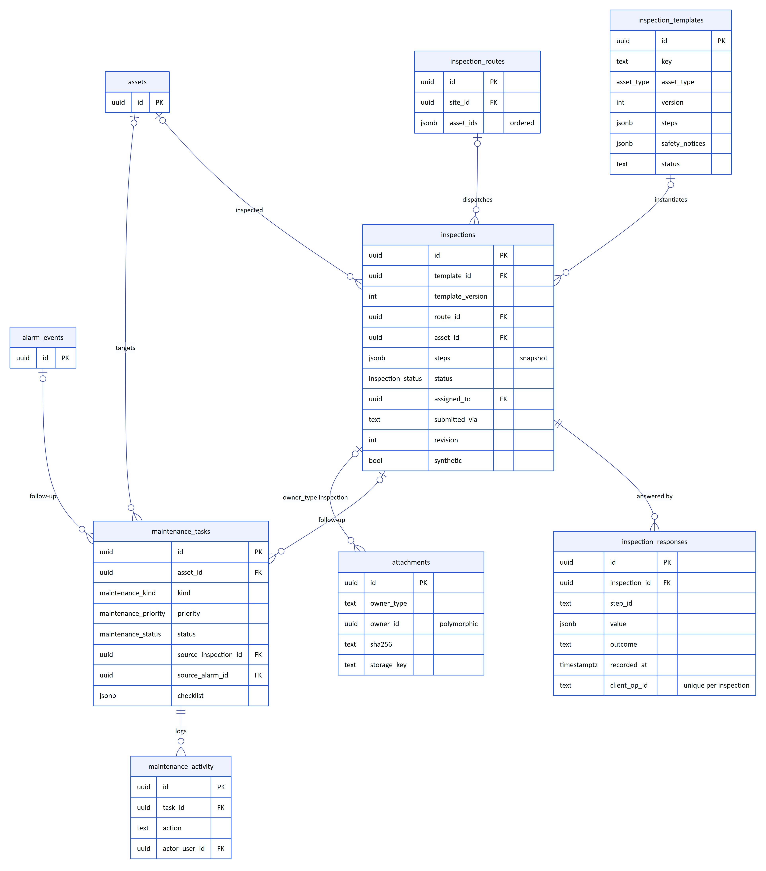
Figure 6. Work: templates and routes produce inspections, abnormal results and alarms produce maintenance tasks
attachments.owner_id is polymorphic: it points at an inspection, maintenance task, asset or alarm depending on owner_type, and therefore has no foreign key. The upload route validates the owner inside the tenant transaction before inserting (apps/api/src/modules/plant.ts).

3.6 Devices and UI profiles
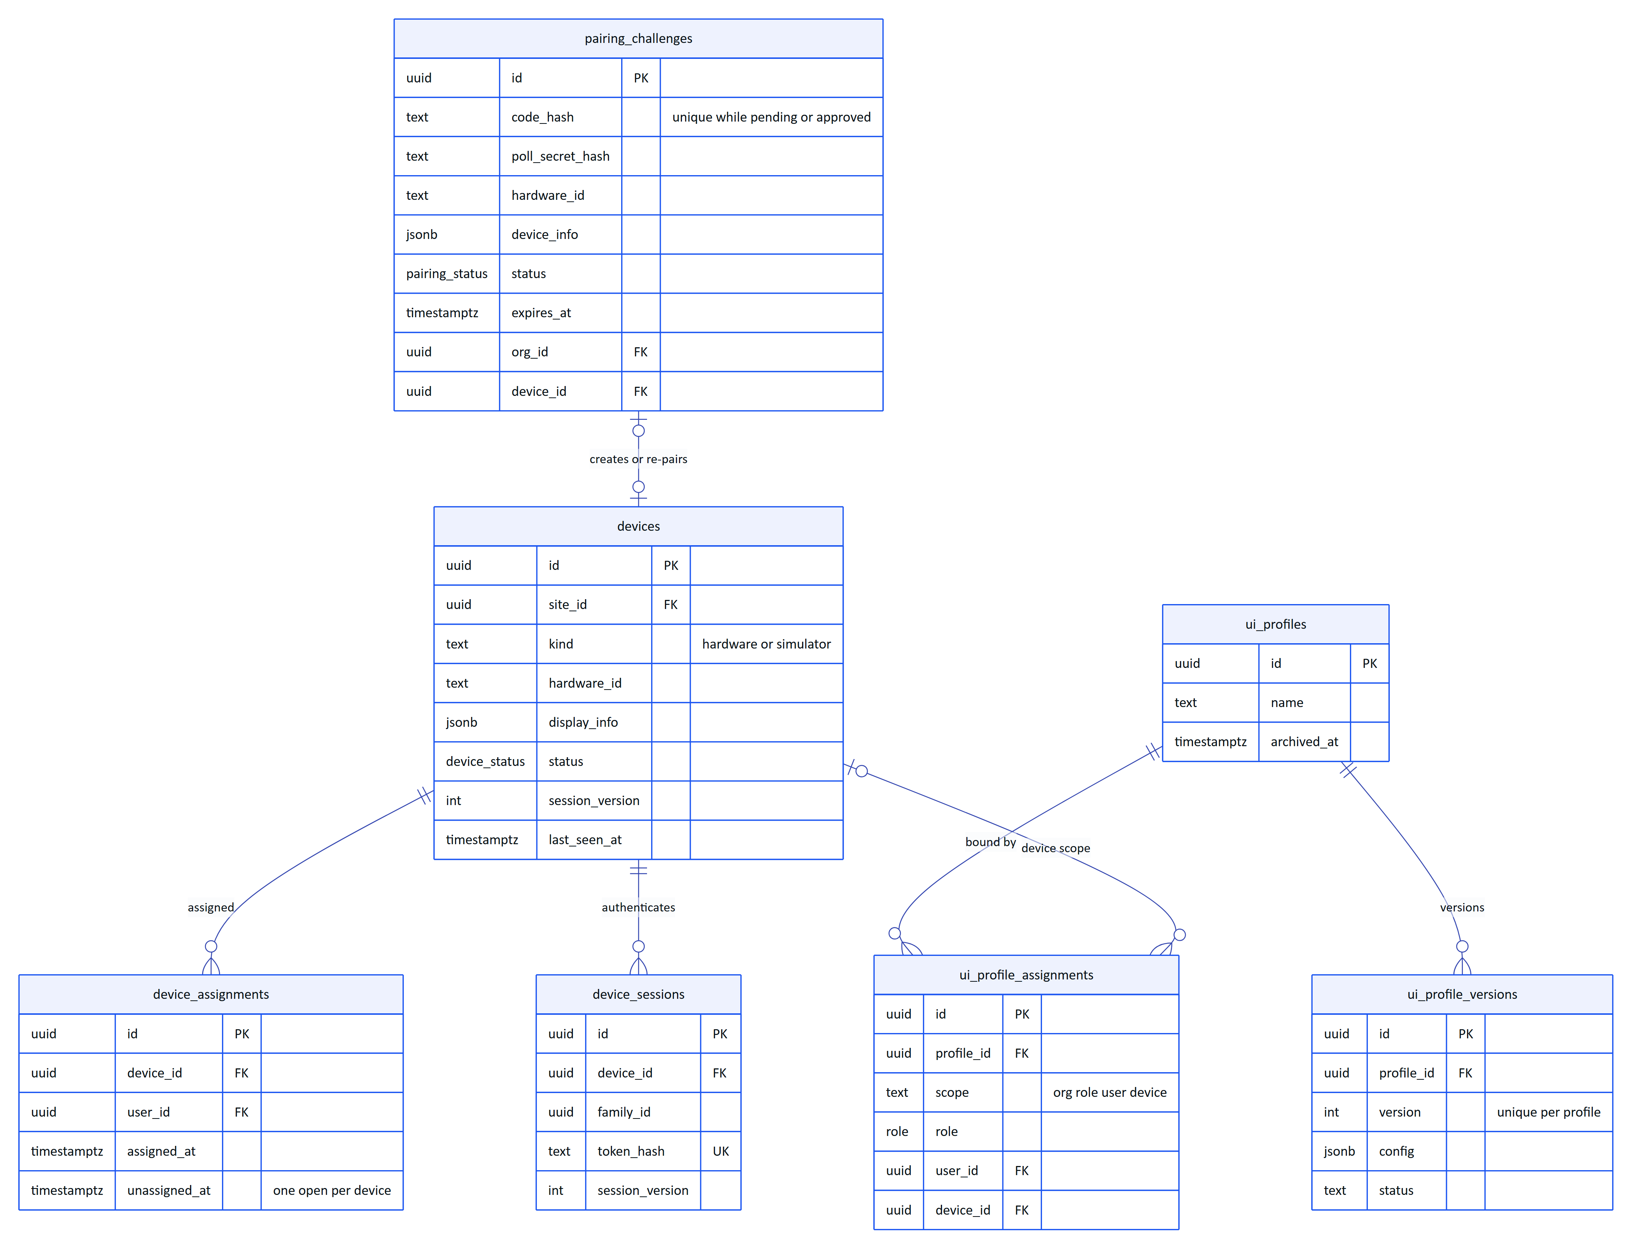
Figure 7. Devices and UI profiles: pairing creates devices, assignments bind operators, profiles shape the glasses UI

3.7 Audit documents
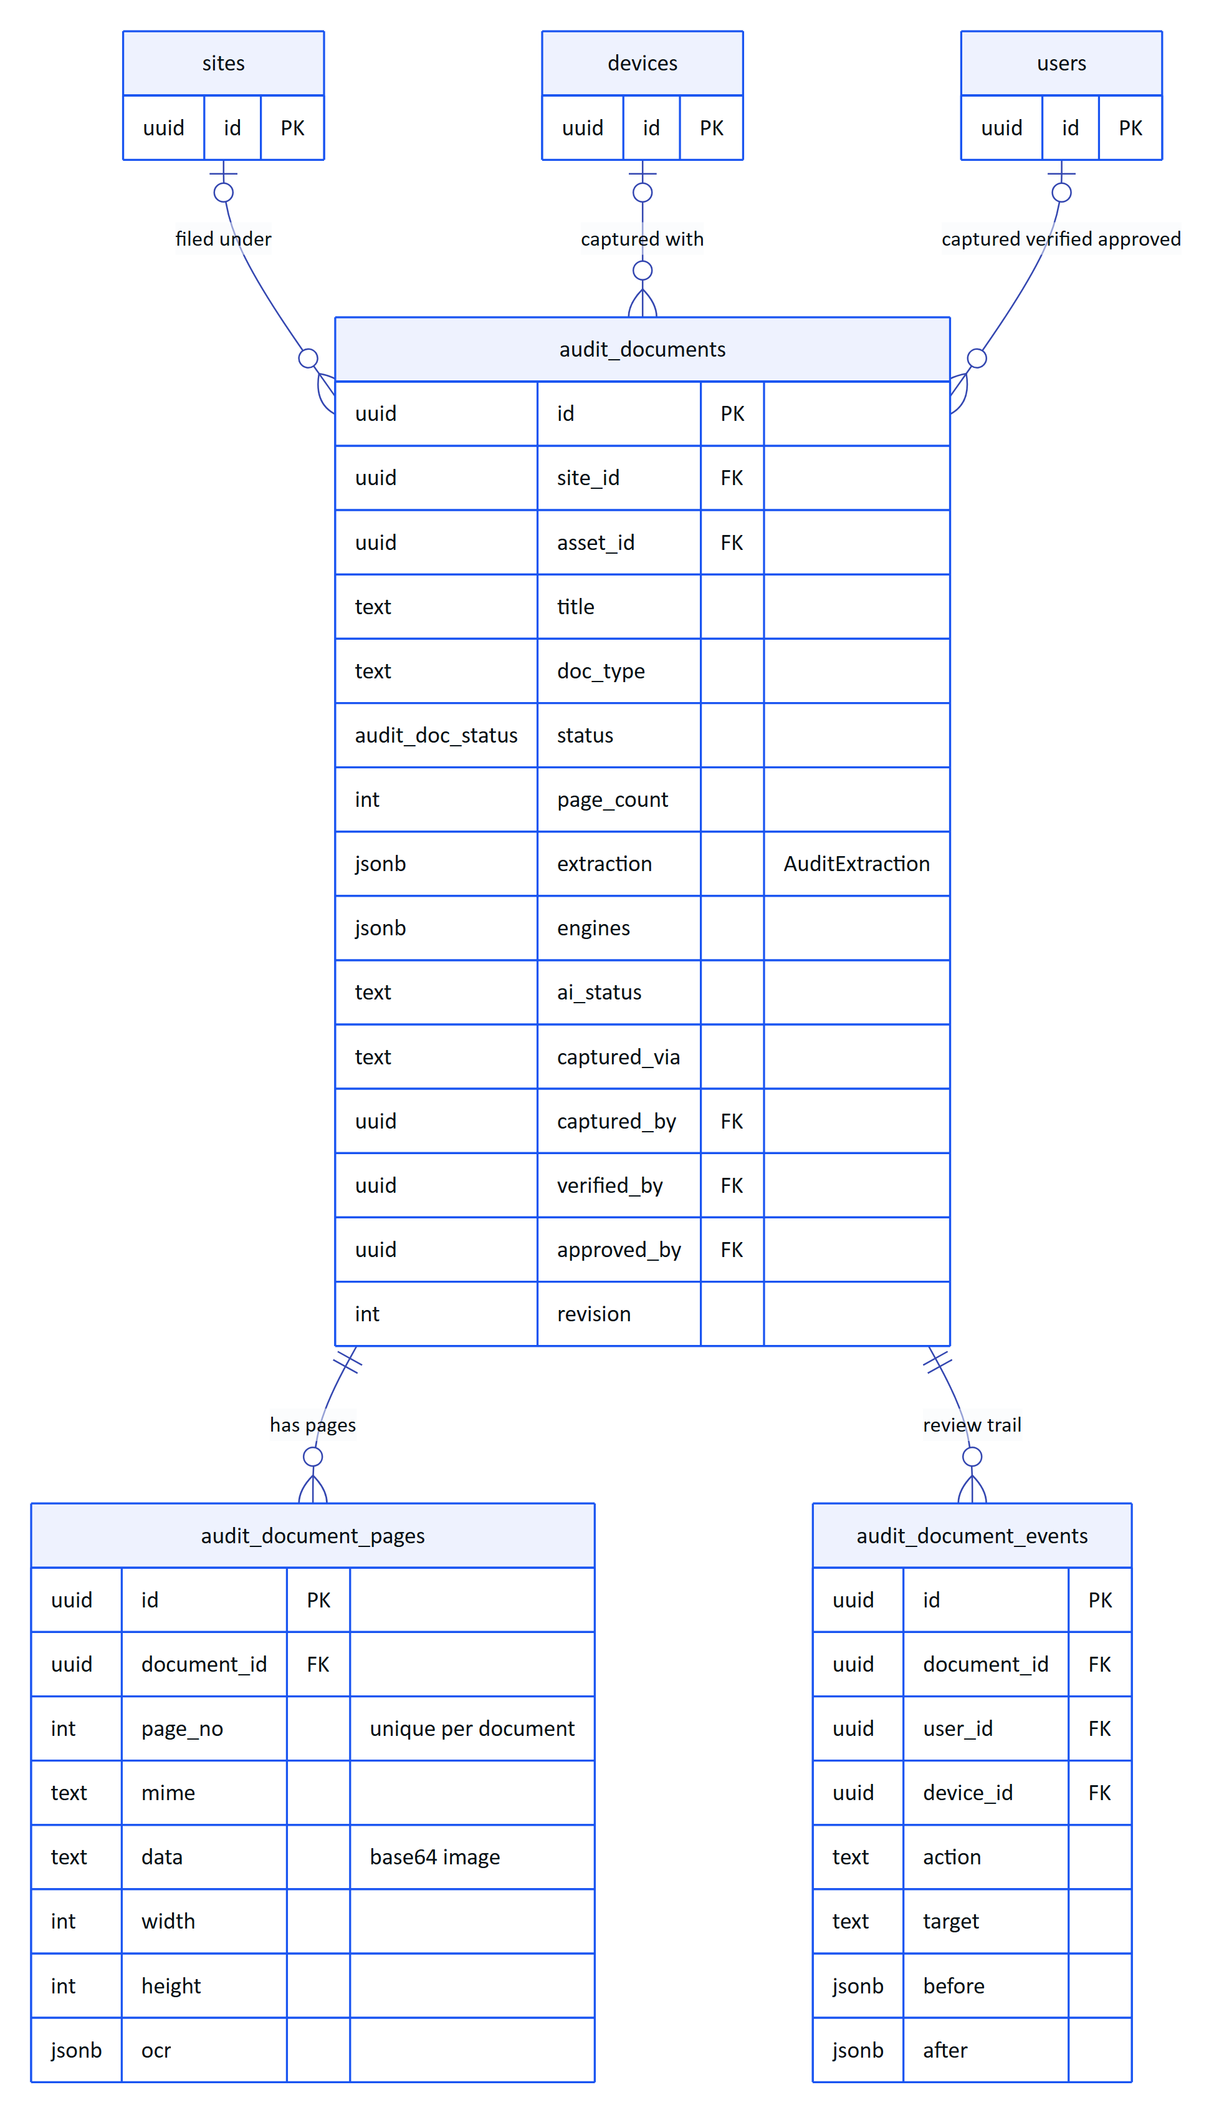
Figure 8. Audit documents: a scan has pages with images and OCR, and an append-only review trail

3.8 Platform and demo storage
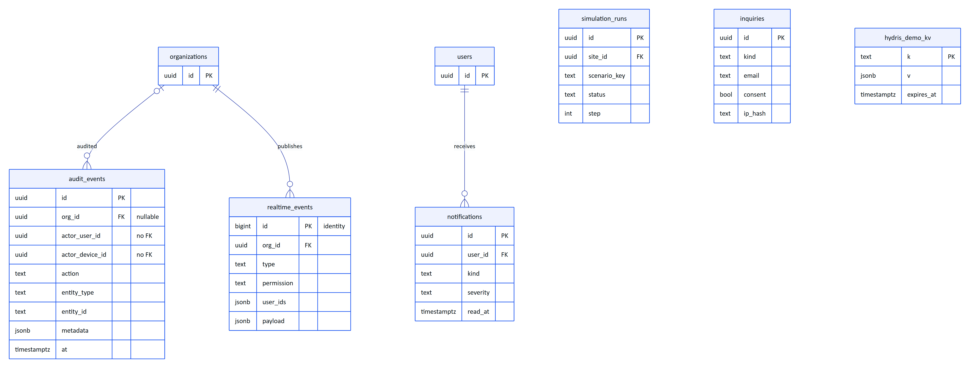
Figure 9. Platform tables: audit trail, notifications, realtime log, simulations, leads and the demo key/value store
inquiries and hydris_demo_kv have no relationships: inquiries are platform-owned leads from the public website, and the demo key/value store is infrastructure for demo mode only.

4 Data dictionary
One table per database table, listing every column. "Null" is No for NOT NULL columns. Defaults are the SQL defaults from the migrations; application-level defaults are noted in the description. Foreign keys give the target and the ON DELETE action (cascade, set null, or no action when omitted). Every id without a note is uuid with default gen_random_uuid(), and every org_id is uuid not null, FK organizations.id, cascade.

4.1 Identity and tenancy tables

users
Table 3. users (global identities, not tenant-scoped, no RLS)
Column | Type | Null | Default | Description
id | uuid | No | gen_random_uuid() | Primary key.
email | text | No |  | Sign-in email. Unique case-insensitively.
name | text | No |  | Display name.
password_hash | text | Yes |  | argon2id hash (core/crypto.ts). Null for accounts without a password.
is_platform_admin | boolean | No | false | Hydris staff flag; enables platform administration routes.
status | text | No | 'active' | active or disabled. Disabled users cannot authenticate.
email_verified_at | timestamptz | Yes |  | Set on verification or first password reset.
mfa_secret_enc | text | Yes |  | TOTP secret, AES-256-GCM encrypted with DATA_KEY.
mfa_enabled | boolean | No | false | TOTP required at sign-in when true.
failed_logins | integer | No | 0 | Consecutive failed sign-ins; reset on success.
locked_until | timestamptz | Yes |  | Set for 15 minutes after 5 failures (TTL in config.ts).
last_login_at | timestamptz | Yes |  | Last successful sign-in.
default_org_id | uuid | Yes |  | Preferred organization at sign-in. No FK.
created_at | timestamptz | No | now()
updated_at | timestamptz | No | now()

Indexes and constraints: users_email_lower_uq unique on lower(email).

organizations
Table 4. organizations (tenants)
Column | Type | Null | Default | Description
id | uuid | No | gen_random_uuid() | Primary key; the tenant id used in app.org_id.
name | text | No |  | Display name.
slug | text | No |  | URL-safe unique key (demo: riverbend-demo).
is_demo | boolean | No | false | Demo tenants may receive simulator telemetry; customer tenants never do.
region | text | Yes |  | Free-text region label.
timezone | text | No | 'UTC' | IANA zone for display and reports.
status | text | No | 'active' | active or suspended.
created_at | timestamptz | No | now()
updated_at | timestamptz | No | now()

Indexes and constraints: organizations_slug_uq unique on slug. RLS policy uses id instead of org_id.

memberships
Table 5. memberships (user role in an organization)
Column | Type | Null | Default | Description
id | uuid | No | gen_random_uuid() | Primary key.
org_id | uuid | No |  | Tenant.
user_id | uuid | No |  | FK users.id, cascade.
role | role | No |  | One of the six roles in roles.ts.
status | membership_status | No | 'active' | invited, active, deactivated.
all_sites | boolean | No | true | When false, access is limited to membership_sites.
title | text | Yes |  | Job title shown in the UI.
created_at | timestamptz | No | now()
updated_at | timestamptz | No | now()
deactivated_at | timestamptz | Yes |  | When access was removed.

Indexes and constraints: memberships_org_user_uq unique (org_id, user_id); memberships_user_idx on user_id.

membership_sites
Table 6. membership_sites (site scope for restricted memberships)
Column | Type | Null | Default | Description
membership_id | uuid | No |  | FK memberships.id, cascade. Part of the primary key.
site_id | uuid | No |  | FK sites.id, cascade. Part of the primary key.
org_id | uuid | No |  | Tenant.

Indexes and constraints: primary key (membership_id, site_id).

invitations
Table 7. invitations (pending invites to an organization)
Column | Type | Null | Default | Description
id | uuid | No | gen_random_uuid() | Primary key.
org_id | uuid | No |  | Tenant.
email | text | No |  | Invitee address.
name | text | Yes |  | Invitee name if known.
role | role | No |  | Role granted on acceptance.
site_ids | jsonb | No | '[]' | Array of site uuids when all_sites is false.
all_sites | boolean | No | true | Site scope on acceptance.
token_hash | text | No |  | SHA-256 of the invitation token.
expires_at | timestamptz | No |  | Seven days after creation (TTL.inviteMs).
accepted_at | timestamptz | Yes |  | Set on acceptance.
revoked_at | timestamptz | Yes |  | Set when an admin revokes.
invited_by | uuid | Yes |  | FK users.id.
created_at | timestamptz | No | now()

Indexes and constraints: invitations_token_uq unique on token_hash; invitations_org_idx on org_id.

auth_sessions
Table 8. auth_sessions (rotating refresh-token sessions for people; no RLS)
Column | Type | Null | Default | Description
id | uuid | No | gen_random_uuid() | Primary key.
user_id | uuid | No |  | FK users.id, cascade.
org_id | uuid | Yes |  | FK organizations.id, cascade. Organization of the session.
family_id | uuid | No |  | Rotation family; the access token sid claim. Revoking a family ends all its tokens.
token_hash | text | No |  | SHA-256 of the refresh token.
expires_at | timestamptz | No |  | Seven days after issue (TTL.refreshMs).
revoked_at | timestamptz | Yes |  | Logout or reuse detection.
rotated_at | timestamptz | Yes |  | Set when the token was exchanged for a new one.
user_agent | text | Yes |  | Client user agent.
ip | text | Yes |  | Client IP at issue.
created_at | timestamptz | No | now()
last_used_at | timestamptz | Yes |  | Last refresh.

Indexes and constraints: auth_sessions_token_uq unique on token_hash; auth_sessions_user_idx; auth_sessions_family_idx.

auth_tokens
Table 9. auth_tokens (single-use password reset and email verification tokens; no RLS)
Column | Type | Null | Default | Description
id | uuid | No | gen_random_uuid() | Primary key.
purpose | text | No |  | password_reset or email_verify.
user_id | uuid | No |  | FK users.id, cascade.
token_hash | text | No |  | SHA-256 of the emailed token.
expires_at | timestamptz | No |  | 30 minutes for resets (TTL.resetMs).
used_at | timestamptz | Yes |  | Set when consumed.
created_at | timestamptz | No | now()

Indexes and constraints: auth_tokens_token_uq unique on token_hash.

mail_outbox
Table 10. mail_outbox (recorded outgoing mail; no transport yet; no RLS)
Column | Type | Null | Default | Description
id | uuid | No | gen_random_uuid() | Primary key.
to | text | No |  | Recipient address.
subject | text | No |  | Subject line.
body_text | text | No |  | Plain-text body. Can contain reset and invitation links.
created_at | timestamptz | No | now()
sent_at | timestamptz | Yes |  | Reserved for a mail transport; never set today.

Indexes and constraints: none.
RISK
mail_outbox.body_text holds live password-reset and invitation links in clear text and is never purged. Until a mail transport exists, restrict database access to this table and add the purge job proposed in "Data lifecycle and retention".

4.2 Plant model tables

sites
Table 11. sites (physical plant locations)
Column | Type | Null | Default | Description
id | uuid | No | gen_random_uuid() | Primary key.
org_id | uuid | No |  | Tenant.
name | text | No |  | Display name.
code | text | No |  | Short code, unique per organization (demo: RIP, RTS).
address | text | Yes |  | Street address.
city | text | Yes |  | City.
country | text | Yes |  | Country.
lat | double precision | Yes |  | Latitude, WGS84.
lng | double precision | Yes |  | Longitude, WGS84.
timezone | text | No | 'UTC' | IANA zone.
layout_width_m | double precision | No | 100 | Plant layout canvas width in metres (map and route planner).
layout_height_m | double precision | No | 80 | Canvas height in metres.
archived_at | timestamptz | Yes |  | Soft delete.
created_at | timestamptz | No | now()
updated_at | timestamptz | No | now()

Indexes and constraints: sites_org_code_uq unique (org_id, code); sites_org_idx on org_id.

facilities
Table 12. facilities (treatment plants within a site)
Column | Type | Null | Default | Description
id | uuid | No | gen_random_uuid() | Primary key.
org_id | uuid | No |  | Tenant.
site_id | uuid | No |  | FK sites.id, cascade.
name | text | No |  | Display name.
code | text | No |  | Unique per site (demo: ETP-01).
kind | facility_kind | No |  | ETP, STP, WTP, CETP or other.
capacity_m3_per_day | double precision | Yes |  | Design capacity.
description | text | Yes |  | Free text.
archived_at | timestamptz | Yes |  | Soft delete.
created_at | timestamptz | No | now()
updated_at | timestamptz | No | now()

Indexes and constraints: facilities_site_code_uq unique (site_id, code); facilities_org_idx.

process_areas
Table 13. process_areas (treatment stages inside a facility)
Column | Type | Null | Default | Description
id | uuid | No | gen_random_uuid() | Primary key.
org_id | uuid | No |  | Tenant.
site_id | uuid | No |  | FK sites.id, cascade.
facility_id | uuid | No |  | FK facilities.id, cascade.
name | text | No |  | Display name.
code | text | No |  | Unique per facility.
kind | process_area_kind | No |  | Treatment stage (13 values).
sort_order | integer | No | 0 | Display order along the treatment train.
polygon | jsonb | Yes |  | Outline on the site layout, metres: [[x, y], ...].
archived_at | timestamptz | Yes |  | Soft delete.
created_at | timestamptz | No | now()
updated_at | timestamptz | No | now()

Indexes and constraints: process_areas_facility_code_uq unique (facility_id, code); process_areas_org_idx.

assets
Table 14. assets (equipment)
Column | Type | Null | Default | Description
id | uuid | No | gen_random_uuid() | Primary key.
org_id | uuid | No |  | Tenant.
site_id | uuid | No |  | FK sites.id, cascade.
facility_id | uuid | No |  | FK facilities.id, cascade.
process_area_id | uuid | Yes |  | FK process_areas.id, set null.
tag | text | No |  | Plant tag (P-101), unique per organization.
name | text | No |  | Display name.
type | asset_type | No |  | Equipment class (14 values).
manufacturer | text | Yes
model | text | Yes
serial_number | text | Yes
installed_on | text | Yes |  | Installation date as entered (ISO date string by convention).
criticality | criticality | No | 'medium' | low, medium, high.
status | asset_status | No | 'operational' | Operational state (6 values).
specs | jsonb | No | '{}' | Name to value map of nameplate data.
notes | text | Yes |  | Free text.
position_x | double precision | Yes |  | Map position in metres from the layout origin.
position_y | double precision | Yes |  | Map position in metres.
archived_at | timestamptz | Yes |  | Soft delete.
created_at | timestamptz | No | now()
updated_at | timestamptz | No | now()

Indexes and constraints: assets_org_tag_uq unique (org_id, tag); assets_site_idx (org_id, site_id); assets_area_idx on process_area_id.

4.3 Telemetry tables

gateways
Table 15. gateways (ingestion credentials per site)
Column | Type | Null | Default | Description
id | uuid | No | gen_random_uuid() | Primary key.
org_id | uuid | No |  | Tenant.
site_id | uuid | No |  | FK sites.id, cascade. A gateway may only write sensors on its own site.
name | text | No |  | Display name.
protocol | text | No | 'https' | https, mqtt or opcua (only HTTPS ingestion is implemented).
key_prefix | text | No |  | Visible prefix of the API key for identification.
key_hash | text | No |  | SHA-256 of the full key.
status | text | No | 'active' | active or revoked.
last_seen_at | timestamptz | Yes |  | Updated on each authenticated ingest call.
created_by | uuid | Yes |  | FK users.id.
created_at | timestamptz | No | now()
revoked_at | timestamptz | Yes

Indexes and constraints: gateways_key_uq unique on key_hash; gateways_org_idx.

sensors
Table 16. sensors (measurement points, with the latest value cached)
Column | Type | Null | Default | Description
id | uuid | No | gen_random_uuid() | Primary key.
org_id | uuid | No |  | Tenant.
site_id | uuid | No |  | FK sites.id, cascade.
asset_id | uuid | Yes |  | FK assets.id, cascade.
process_area_id | uuid | Yes |  | FK process_areas.id, set null.
gateway_id | uuid | Yes |  | FK gateways.id, set null.
tag | text | No |  | Instrument tag (VT-101), unique per organization.
name | text | No |  | Display name.
measurand | measurand | No |  | What is measured (16 values).
unit | text | No |  | Canonical unit from MEASURAND_DEFS.
method | measurement_method | No | 'continuous' | continuous, lab or manual.
expected_interval_s | integer | No | 60 | Expected reporting interval; drives freshness and stale alarms.
source_ref | text | Yes |  | Gateway-side address (demo: ETP01.VT-101).
last_value | double precision | Yes |  | Cached effective latest value.
last_ts | timestamptz | Yes |  | Observation time of last_value.
last_quality | sensor_quality | Yes |  | Quality of the latest reading.
last_source | telemetry_source | Yes |  | Source of the latest reading.
last_received_at | timestamptz | Yes |  | Server receive time of the latest reading.
enabled | boolean | No | true | Disabled sensors reject ingestion.
archived_at | timestamptz | Yes |  | Soft delete; archived sensors reject ingestion.
created_at | timestamptz | No | now()
updated_at | timestamptz | No | now()

Indexes and constraints: sensors_org_tag_uq unique (org_id, tag); sensors_asset_idx; sensors_site_idx (org_id, site_id).

telemetry_readings
Table 17. telemetry_readings (time series of measured values)
Column | Type | Null | Default | Description
id | bigint | No | identity | Primary key, GENERATED ALWAYS AS IDENTITY.
org_id | uuid | No |  | Tenant.
sensor_id | uuid | No |  | FK sensors.id, cascade.
ts | timestamptz | No |  | Observation time from the source.
value | double precision | No |  | Value in the canonical unit.
quality | sensor_quality | No | 'good' | good, uncertain, bad. Bad readings never raise alarms.
source | telemetry_source | No |  | gateway, manual, lab or simulator.
synthetic | boolean | No | false | True if and only if source = 'simulator'.
message_id | text | Yes |  | Source message id for tracing (demo: demo:VT-101:<ms>).
received_at | timestamptz | No | now() | Server receive time.

Indexes and constraints: telemetry_sensor_ts_uq unique (sensor_id, ts) (idempotent ingestion); telemetry_sensor_ts_idx (sensor_id, ts DESC); telemetry_org_ts_idx (org_id, ts); CHECK telemetry_synthetic_source_ck: synthetic = (source = 'simulator').

telemetry_corrections
Table 18. telemetry_corrections (append-only corrections; UPDATE and DELETE revoked)
Column | Type | Null | Default | Description
id | uuid | No | gen_random_uuid() | Primary key.
org_id | uuid | No |  | Tenant.
sensor_id | uuid | No |  | FK sensors.id, cascade.
reading_id | bigint | No |  | FK telemetry_readings.id, cascade.
original_value | double precision | No |  | Value of the reading at correction time.
corrected_value | double precision | Yes |  | New value (canonical unit) for correct; null for invalidate.
action | text | No |  | correct replaces the value; invalidate excludes the reading.
reason | text | No |  | Required explanation, 5 to 1,000 characters.
corrected_by | uuid | Yes |  | FK users.id.
created_at | timestamptz | No | now() | The newest correction per reading wins.

Indexes and constraints: telemetry_corrections_reading_idx (reading_id, created_at); telemetry_corrections_sensor_idx.

4.4 Alarm and procedure tables

alarm_rules
Table 19. alarm_rules (threshold and data-freshness rules)
Column | Type | Null | Default | Description
id | uuid | No | gen_random_uuid() | Primary key.
org_id | uuid | No |  | Tenant.
site_id | uuid | No |  | FK sites.id, cascade. Copied from the sensor.
sensor_id | uuid | No |  | FK sensors.id, cascade.
name | text | No |  | Display name (demo: VT-101 high-high).
condition | alarm_condition | No |  | high_high, high, low, low_low or stale.
threshold | double precision | Yes |  | Limit in the canonical unit; required unless stale.
deadband | double precision | No | 0 | Hysteresis band before an alarm counts as cleared.
on_delay_s | integer | No | 0 | Seconds a breach must persist before raising.
severity | alarm_severity | No |  | critical, high, medium, low.
enabled | boolean | No | true | Rules with history are disabled instead of deleted.
recommended_action | text | Yes |  | First action shown to the operator.
procedure_document_id | uuid | Yes |  | FK documents.id, set null. Linked SOP.
breach_since | timestamptz | Yes |  | Evaluation state: start of the current breach (on-delay).
created_by | uuid | Yes |  | FK users.id.
created_at | timestamptz | No | now()
updated_at | timestamptz | No | now()

Indexes and constraints: alarm_rules_sensor_idx; CHECK alarm_rules_threshold_ck: condition = 'stale' OR threshold IS NOT NULL.

alarm_events
Table 20. alarm_events (alarm instances and their human lifecycle)
Column | Type | Null | Default | Description
id | uuid | No | gen_random_uuid() | Primary key.
org_id | uuid | No |  | Tenant.
site_id | uuid | No |  | FK sites.id, cascade.
asset_id | uuid | Yes |  | FK assets.id, set null.
sensor_id | uuid | Yes |  | FK sensors.id, set null.
rule_id | uuid | Yes |  | FK alarm_rules.id, set null.
severity | alarm_severity | No |  | Copied from the rule at trigger time.
condition | alarm_condition | No |  | Copied from the rule.
state | alarm_state | No | 'active' | Human lifecycle state.
title | text | No |  | Headline.
description | text | Yes |  | Breach description (describeBreach()).
recommended_action | text | Yes |  | Copied from the rule.
trigger_value | double precision | Yes |  | Value that raised the alarm.
threshold | double precision | Yes |  | Limit at trigger time.
unit | text | Yes |  | Unit of the values.
peak_value | double precision | Yes |  | Worst value seen while the condition persisted.
triggered_at | timestamptz | No |  | Observation time of the triggering reading.
cleared_at | timestamptz | Yes |  | When the measured condition returned to normal; independent of state.
assigned_to | uuid | Yes |  | FK users.id.
acknowledged_by | uuid | Yes |  | FK users.id.
acknowledged_at | timestamptz | Yes
resolved_by | uuid | Yes |  | FK users.id.
resolved_at | timestamptz | Yes
resolution_note | text | Yes |  | Required by the resolve transition.
closed_by | uuid | Yes |  | FK users.id.
closed_at | timestamptz | Yes
synthetic | boolean | No | false | Raised from simulator data.
updated_at | timestamptz | No | now() | There is no created_at; triggered_at serves.

Indexes and constraints: alarm_events_org_state_idx (org_id, state, triggered_at); alarm_events_rule_idx (rule_id, state); alarm_events_asset_idx.

alarm_event_history
Table 21. alarm_event_history (transition and note log per alarm)
Column | Type | Null | Default | Description
id | uuid | No | gen_random_uuid() | Primary key.
org_id | uuid | No |  | Tenant.
alarm_id | uuid | No |  | FK alarm_events.id, cascade.
action | text | No |  | triggered, condition_cleared, acknowledge, investigate, resolve, close, assigned, note.
from_state | alarm_state | Yes |  | State before a transition.
to_state | alarm_state | Yes |  | State after a transition.
actor_user_id | uuid | Yes |  | FK users.id; null for the alarm engine.
actor_device_id | uuid | Yes |  | Glasses that performed the action. No FK.
note | text | Yes |  | Operator note or engine message.
at | timestamptz | No | now()

Indexes and constraints: alarm_history_alarm_idx (alarm_id, at).

documents
Table 22. documents (SOPs, manuals and safety notices; full-text searchable)
Column | Type | Null | Default | Description
id | uuid | No | gen_random_uuid() | Primary key.
org_id | uuid | No |  | Tenant.
site_id | uuid | Yes |  | FK sites.id, cascade. Null means organization-wide.
asset_id | uuid | Yes |  | FK assets.id, set null. Specific asset.
asset_type | asset_type | Yes |  | Applies to every asset of this type.
title | text | No |  | Title (demo: SOP-PMP-07 Pump vibration response).
kind | document_kind | No |  | sop, manual, datasheet, safety, troubleshooting, other.
body | text | No |  | Plain text body; searched with to_tsvector('english', ...).
version | integer | No | 1 | Document revision number.
status | document_status | No | 'draft' | Only approved documents reach the glasses and the assistant.
tags | jsonb | No | '[]' | Array of strings.
approved_by | uuid | Yes |  | FK users.id.
approved_at | timestamptz | Yes
created_by | uuid | Yes |  | FK users.id.
created_at | timestamptz | No | now()
updated_at | timestamptz | No | now()

Indexes and constraints: documents_org_idx (org_id, status); documents_asset_idx. No full-text index (see "Indexing and query patterns").

4.5 Work tables

inspection_templates
Table 23. inspection_templates (versioned checklists)
Column | Type | Null | Default | Description
id | uuid | No | gen_random_uuid() | Primary key.
org_id | uuid | No |  | Tenant.
key | text | Yes |  | Stable key across versions (demo: pump_routine). Not unique.
name | text | No |  | Display name.
description | text | Yes
asset_type | asset_type | Yes |  | Asset class the template is for.
version | integer | No | 1 | Template revision.
steps | jsonb | No |  | InspectionStep[] (see "JSON column schemas").
safety_notices | jsonb | No | '[]' | Array of strings shown before the first step.
estimated_minutes | integer | Yes |  | Planning estimate.
status | text | No | 'published' | draft, published or archived.
created_by | uuid | Yes |  | FK users.id.
created_at | timestamptz | No | now()
updated_at | timestamptz | No | now()

Indexes and constraints: inspection_templates_org_idx.

inspection_routes
Table 24. inspection_routes (ordered rounds through assets on a site)
Column | Type | Null | Default | Description
id | uuid | No | gen_random_uuid() | Primary key.
org_id | uuid | No |  | Tenant.
site_id | uuid | No |  | FK sites.id, cascade.
name | text | No |  | Display name (demo: Morning round · ETP-01).
description | text | Yes
asset_ids | jsonb | No | '[]' | Ordered array of asset uuids. Not foreign keys.
created_by | uuid | Yes |  | FK users.id.
created_at | timestamptz | No | now()
updated_at | timestamptz | No | now()

Indexes and constraints: inspection_routes_site_idx (org_id, site_id).

inspections
Table 25. inspections (assigned inspection instances)
Column | Type | Null | Default | Description
id | uuid | No | gen_random_uuid() | Primary key.
org_id | uuid | No |  | Tenant.
site_id | uuid | No |  | FK sites.id, cascade.
asset_id | uuid | Yes |  | FK assets.id, set null.
template_id | uuid | Yes |  | FK inspection_templates.id, set null.
template_version | integer | Yes |  | Template version at assignment.
route_id | uuid | Yes |  | FK inspection_routes.id, set null.
title | text | No |  | Display title.
steps | jsonb | No |  | Snapshot of the template steps at assignment time.
safety_notices | jsonb | No | '[]' | Snapshot of the safety notices.
status | inspection_status | No | 'scheduled' | Lifecycle state.
priority | text | No | 'normal' | normal or high.
assigned_to | uuid | Yes |  | FK users.id. Only this person may record responses.
assigned_by | uuid | Yes |  | FK users.id. Notified on submit.
due_at | timestamptz | Yes
started_at | timestamptz | Yes |  | First response or explicit start.
paused_at | timestamptz | Yes
submitted_at | timestamptz | Yes
submitted_via | text | Yes |  | console or glasses.
submitted_device_id | uuid | Yes |  | Glasses that submitted. No FK.
reviewed_by | uuid | Yes |  | FK users.id.
reviewed_at | timestamptz | Yes
review_note | text | Yes |  | Reason when returned.
revision | integer | No | 1 | Incremented on every change; optimistic lock for offline clients.
synthetic | boolean | No | false | Created by a simulation.
created_at | timestamptz | No | now()
updated_at | timestamptz | No | now()

Indexes and constraints: inspections_org_status_idx (org_id, status); inspections_assignee_idx (assigned_to, status); inspections_asset_idx.

inspection_responses
Table 26. inspection_responses (step answers; idempotent for offline replay)
Column | Type | Null | Default | Description
id | uuid | No | gen_random_uuid() | Primary key.
org_id | uuid | No |  | Tenant.
inspection_id | uuid | No |  | FK inspections.id, cascade.
step_id | text | No |  | InspectionStep.id within the snapshot.
value | jsonb | No |  | StepValue (see "JSON column schemas").
outcome | text | No |  | ok, abnormal or na, derived by stepOutcome().
note | text | Yes |  | Operator note.
recorded_at | timestamptz | No |  | Client time of the answer; at most 5 minutes in the future.
received_at | timestamptz | No | now() | Server receive time.
recorded_by | uuid | Yes |  | FK users.id.
device_id | uuid | Yes |  | Glasses that recorded the answer. No FK.
client_op_id | text | No |  | Client-generated idempotency key.

Indexes and constraints: inspection_responses_op_uq unique (inspection_id, client_op_id); inspection_responses_step_idx (inspection_id, step_id, recorded_at). A step may have several responses; the latest recorded_at is current.

attachments
Table 27. attachments (file metadata; bytes live in object storage)
Column | Type | Null | Default | Description
id | uuid | No | gen_random_uuid() | Primary key.
org_id | uuid | No |  | Tenant.
owner_type | text | No |  | inspection, maintenance, asset, document, alarm (upload route accepts all but document).
owner_id | uuid | No |  | Owner row id. Polymorphic, no FK.
filename | text | No |  | Sanitised original name, at most 120 characters.
mime | text | No |  | JPEG, PNG, WebP, PDF or plain text; magic bytes checked.
size_bytes | integer | No |  | Size in bytes.
sha256 | text | No |  | Content hash.
storage_key | text | No |  | Disk path <org>/<uuid> or private Vercel Blob key attachments/<org>/<uuid>.
uploaded_by | uuid | Yes |  | FK users.id.
device_id | uuid | Yes |  | Glasses that uploaded. No FK.
created_at | timestamptz | No | now()

Indexes and constraints: attachments_owner_idx (owner_type, owner_id).

maintenance_tasks
Table 28. maintenance_tasks (work orders)
Column | Type | Null | Default | Description
id | uuid | No | gen_random_uuid() | Primary key.
org_id | uuid | No |  | Tenant.
site_id | uuid | No |  | FK sites.id, cascade.
asset_id | uuid | Yes |  | FK assets.id, set null.
title | text | No
description | text | Yes
kind | maintenance_kind | No | 'corrective' | corrective, preventive, inspection_followup, alarm_followup.
priority | maintenance_priority | No | 'medium' | low, medium, high, urgent.
status | maintenance_status | No | 'open' | Lifecycle state.
assigned_to | uuid | Yes |  | FK users.id.
requested_by | uuid | Yes |  | FK users.id.
source_inspection_id | uuid | Yes |  | FK inspections.id, set null. Set for automatic follow-ups.
source_alarm_id | uuid | Yes |  | FK alarm_events.id, set null.
checklist | jsonb | No | '[]' | Checklist items (see "JSON column schemas").
due_at | timestamptz | Yes
started_at | timestamptz | Yes
completed_at | timestamptz | Yes
completion_note | text | Yes
synthetic | boolean | No | false | Created by a simulation.
created_at | timestamptz | No | now()
updated_at | timestamptz | No | now()

Indexes and constraints: maintenance_org_status_idx (org_id, status); maintenance_assignee_idx (assigned_to, status); maintenance_asset_idx.

maintenance_activity
Table 29. maintenance_activity (task log)
Column | Type | Null | Default | Description
id | uuid | No | gen_random_uuid() | Primary key.
org_id | uuid | No |  | Tenant.
task_id | uuid | No |  | FK maintenance_tasks.id, cascade.
action | text | No |  | Transition or event name (start, hold, complete, note, assigned, ...).
note | text | Yes
actor_user_id | uuid | Yes |  | FK users.id.
at | timestamptz | No | now()

Indexes and constraints: maintenance_activity_task_idx (task_id, at).

4.6 Device and UI profile tables

devices
Table 30. devices (paired glasses and simulators)
Column | Type | Null | Default | Description
id | uuid | No | gen_random_uuid() | Primary key.
org_id | uuid | No |  | Tenant.
site_id | uuid | Yes |  | FK sites.id, set null. Home site.
name | text | No |  | Display name.
kind | text | No |  | hardware or simulator.
model | text | Yes |  | Model string (demo: Vuzix M400).
hardware_id | text | No |  | Install identifier generated on the device; stable across re-pairing.
firmware_version | text | Yes
app_version | text | Yes
display_info | jsonb | Yes |  | { "width": n, "height": n }.
status | device_status | No | 'active' | active, suspended, revoked.
session_version | integer | No | 1 | Bumped on revoke, suspension or reassignment to invalidate tokens.
paired_at | timestamptz | No | now()
paired_by | uuid | Yes |  | FK users.id.
last_seen_at | timestamptz | Yes |  | Updated on every authenticated device request.
last_ip | text | Yes |  | IP of the last device request.
suspended_at | timestamptz | Yes
revoked_at | timestamptz | Yes
revoked_by | uuid | Yes |  | FK users.id.
revoke_reason | text | Yes
created_at | timestamptz | No | now()
updated_at | timestamptz | No | now()

Indexes and constraints: devices_org_idx (org_id, status); devices_hw_idx on hardware_id.

device_assignments
Table 31. device_assignments (which operator wears which device)
Column | Type | Null | Default | Description
id | uuid | No | gen_random_uuid() | Primary key.
org_id | uuid | No |  | Tenant.
device_id | uuid | No |  | FK devices.id, cascade.
user_id | uuid | No |  | FK users.id, cascade.
assigned_by | uuid | Yes |  | FK users.id.
assigned_at | timestamptz | No | now()
unassigned_at | timestamptz | Yes |  | Null while the assignment is current.
reason | text | Yes

Indexes and constraints: device_assignments_device_idx (device_id, assigned_at); device_assignments_active_uq unique (device_id) WHERE unassigned_at IS NULL.

pairing_challenges
Table 32. pairing_challenges (device authorization flow state; pre-tenant, no RLS)
Column | Type | Null | Default | Description
id | uuid | No | gen_random_uuid() | Primary key; the challengeId.
code_hash | text | No |  | SHA-256 of the 8-character user code.
poll_secret_hash | text | No |  | SHA-256 of the secret only the device holds.
hardware_id | text | No |  | Requesting install.
device_info | jsonb | No |  | Self-description sent by the device.
status | pairing_status | No | 'pending' | Flow state.
expires_at | timestamptz | No |  | 300 seconds after creation (PAIRING_TTL_S).
last_polled_at | timestamptz | Yes |  | Enforces the 3 second poll interval.
approved_by | uuid | Yes |  | FK users.id.
approved_at | timestamptz | Yes
org_id | uuid | Yes |  | FK organizations.id, cascade. Set on approval.
site_id | uuid | Yes |  | FK sites.id, set null.
assignee_user_id | uuid | Yes |  | FK users.id. Operator to assign.
device_id | uuid | Yes |  | FK devices.id, set null. Device created or re-paired.
completed_at | timestamptz | Yes
requester_ip | text | Yes
created_at | timestamptz | No | now()

Indexes and constraints: pairing_code_active_uq unique (code_hash) WHERE status IN ('pending','approved'); pairing_expires_idx on expires_at.

device_sessions
Table 33. device_sessions (rotating device refresh tokens)
Column | Type | Null | Default | Description
id | uuid | No | gen_random_uuid() | Primary key.
org_id | uuid | No |  | Tenant.
device_id | uuid | No |  | FK devices.id, cascade.
family_id | uuid | No |  | Rotation family.
token_hash | text | No |  | SHA-256 of the refresh token.
session_version | integer | No |  | Device session_version at issue; older versions are rejected.
expires_at | timestamptz | No |  | 30 days after issue (TTL.deviceRefreshMs).
revoked_at | timestamptz | Yes
rotated_at | timestamptz | Yes
created_at | timestamptz | No | now()
last_used_at | timestamptz | Yes

Indexes and constraints: device_sessions_token_uq unique on token_hash; device_sessions_device_idx.

ui_profiles
Table 34. ui_profiles (containers for versioned glasses UI configuration)
Column | Type | Null | Default | Description
id | uuid | No | gen_random_uuid() | Primary key.
org_id | uuid | No |  | Tenant.
name | text | No |  | Display name.
description | text | Yes
created_by | uuid | Yes |  | FK users.id.
archived_at | timestamptz | Yes |  | Archived profiles are skipped during resolution.
created_at | timestamptz | No | now()
updated_at | timestamptz | No | now()

Indexes and constraints: ui_profiles_org_idx.

ui_profile_versions
Table 35. ui_profile_versions (immutable published configurations)
Column | Type | Null | Default | Description
id | uuid | No | gen_random_uuid() | Primary key.
org_id | uuid | No |  | Tenant.
profile_id | uuid | No |  | FK ui_profiles.id, cascade.
version | integer | No |  | Monotonic per profile. Rollback creates a new draft from an old version.
config | jsonb | No |  | UiProfileConfig, normalised by normalizeUiProfileConfig().
status | text | No | 'draft' | draft, published or superseded; one published version per profile.
notes | text | Yes |  | Change note.
created_by | uuid | Yes |  | FK users.id.
created_at | timestamptz | No | now()
published_by | uuid | Yes |  | FK users.id.
published_at | timestamptz | Yes

Indexes and constraints: ui_profile_versions_uq unique (profile_id, version); ui_profile_versions_status_idx (profile_id, status).

ui_profile_assignments
Table 36. ui_profile_assignments (scope bindings; device beats user beats role beats org)
Column | Type | Null | Default | Description
id | uuid | No | gen_random_uuid() | Primary key.
org_id | uuid | No |  | Tenant.
profile_id | uuid | No |  | FK ui_profiles.id, cascade.
scope | text | No |  | org, role, user or device.
role | role | Yes |  | Set when scope = 'role'.
user_id | uuid | Yes |  | FK users.id, cascade. Set when scope = 'user'.
device_id | uuid | Yes |  | FK devices.id, cascade. Set when scope = 'device'.
created_by | uuid | Yes |  | FK users.id.
created_at | timestamptz | No | now()

Indexes and constraints: four partial unique indexes, one binding per subject: ui_assign_org_uq (org_id) WHERE scope='org', ui_assign_role_uq (org_id, role) WHERE scope='role', ui_assign_user_uq (org_id, user_id) WHERE scope='user', ui_assign_device_uq (org_id, device_id) WHERE scope='device'.

4.7 Audit document tables

audit_documents
Table 37. audit_documents (scanned paper records and their extraction)
Column | Type | Null | Default | Description
id | uuid | No | gen_random_uuid() | Primary key.
org_id | uuid | No |  | Tenant.
site_id | uuid | Yes |  | FK sites.id, set null. Defaults to the first permitted site.
asset_id | uuid | Yes |  | FK assets.id, set null.
title | text | No |  | Given, guessed from page 1 (guessTitle()), or Audit scan <date>.
doc_type | text | No | 'general' | Document class; may be refined by the vision engine.
status | audit_doc_status | No | 'in_review' | Review workflow state.
page_count | integer | No | 0 | Number of pages (1 to 6).
extraction | jsonb | No |  | AuditExtraction: fields, tables, figures, page text, warnings.
engines | jsonb | No | '[]' | Engines that contributed, for example ["mlkit", "vision:<model>"].
ai_status | text | No | 'none' | none, pending, done, failed, unavailable.
ai_error | text | Yes |  | Last vision-engine error.
captured_by | uuid | Yes |  | FK users.id.
captured_via | text | No |  | glasses, console or mobile.
device_id | uuid | Yes |  | FK devices.id, set null.
verified_by | uuid | Yes |  | FK users.id. Field reviewer.
verified_at | timestamptz | Yes
approved_by | uuid | Yes |  | FK users.id. Must differ from verified_by outside demo tenants.
approved_at | timestamptz | Yes |  | Also set on rejection.
rejected_reason | text | Yes |  | Required on rejection.
revision | integer | No | 1 | Optimistic lock; every write checks and increments it.
created_at | timestamptz | No | now()
updated_at | timestamptz | No | now()

Indexes and constraints: audit_documents_org_idx (org_id, created_at).

audit_document_pages
Table 38. audit_document_pages (page images and raw OCR)
Column | Type | Null | Default | Description
id | uuid | No | gen_random_uuid() | Primary key.
org_id | uuid | No |  | Tenant.
document_id | uuid | No |  | FK audit_documents.id, cascade.
page_no | integer | No |  | 1-based page number.
mime | text | No |  | image/jpeg or image/png; magic bytes checked.
data | text | No |  | Base64 image, under 900 KB decoded per page.
width | integer | No |  | Pixels, 50 to 6,000.
height | integer | No |  | Pixels, 50 to 6,000.
ocr | jsonb | Yes |  | { "readings": OcrReading[] }, one to three device OCR passes.
created_at | timestamptz | No | now()

Indexes and constraints: audit_document_pages_uq unique (document_id, page_no).

audit_document_events
Table 39. audit_document_events (append-only review trail; SELECT and INSERT only)
Column | Type | Null | Default | Description
id | uuid | No | gen_random_uuid() | Primary key.
org_id | uuid | No |  | Tenant.
document_id | uuid | No |  | FK audit_documents.id, cascade.
user_id | uuid | Yes |  | FK users.id.
device_id | uuid | Yes |  | FK devices.id, set null.
action | text | No |  | captured, enhanced, item.confirm, item.correct, item.flag, item.reset, items.confirm_agreed, review.reopened, verified, approved, rejected, renamed.
target | text | Yes |  | Field or table id for item actions.
before | jsonb | Yes |  | Item or title before the change.
after | jsonb | Yes |  | Item, title or summary after the change.
note | text | Yes |  | Reviewer note.
created_at | timestamptz | No | now()

Indexes and constraints: audit_document_events_doc_idx (document_id, created_at).

4.8 Platform tables

audit_events
Table 40. audit_events (append-only audit trail; UPDATE and DELETE revoked)
Column | Type | Null | Default | Description
id | uuid | No | gen_random_uuid() | Primary key.
org_id | uuid | Yes |  | FK organizations.id, cascade. Null for platform-level events.
actor_user_id | uuid | Yes |  | Acting person. No FK, so the trail survives user deletion.
actor_device_id | uuid | Yes |  | Acting glasses. No FK.
actor_label | text | Yes |  | Non-person actor (alarm engine, glasses).
action | text | No |  | Dotted verb, for example alarm.triggered, auditdoc.verified, device.revoke.
entity_type | text | Yes |  | Affected entity class.
entity_id | text | Yes |  | Affected id (text, so non-uuid ids fit).
summary | text | Yes |  | Human-readable one-liner.
metadata | jsonb | Yes |  | Structured detail, for example field-level changes.
ip | text | Yes |  | Request IP.
at | timestamptz | No | now()

Indexes and constraints: audit_org_at_idx (org_id, at); audit_entity_idx (entity_type, entity_id).

notifications
Table 41. notifications (per-user in-app notifications)
Column | Type | Null | Default | Description
id | uuid | No | gen_random_uuid() | Primary key.
org_id | uuid | No |  | Tenant.
user_id | uuid | No |  | FK users.id, cascade. Recipient.
kind | text | No |  | inspection_assigned, inspection_submitted, and similar.
severity | text | No | 'info' | info, success, warning, critical.
title | text | No
body | text | Yes
link | text | Yes |  | Console path.
entity_type | text | Yes
entity_id | uuid | Yes |  | No FK.
read_at | timestamptz | Yes |  | Null while unread.
created_at | timestamptz | No | now()

Indexes and constraints: notifications_user_idx (user_id, read_at, created_at).

realtime_events
Table 42. realtime_events (durable SSE event log for serverless mode; system context only)
Column | Type | Null | Default | Description
id | bigint | No | identity | Primary key and SSE cursor (Last-Event-ID).
org_id | uuid | No |  | FK organizations.id, cascade.
type | text | No |  | Event type, for example telemetry.reading, alarm.updated, auditdoc.updated.
site_id | uuid | Yes |  | Site filter. No FK.
permission | text | Yes |  | Permission a subscriber needs to receive the event.
user_ids | jsonb | Yes |  | Array of recipient user ids, or null for everyone permitted.
device_ids | jsonb | Yes |  | Array of recipient device ids.
payload | jsonb | Yes |  | Event body.
created_at | timestamptz | No | now() | Pruned after one day.

Indexes and constraints: realtime_events_created_idx on created_at. Written only when REALTIME_MODE=db (always in demo mode on serverless).

simulation_runs
Table 43. simulation_runs (demo scenario runs)
Column | Type | Null | Default | Description
id | uuid | No | gen_random_uuid() | Primary key.
org_id | uuid | No |  | Tenant (demo organizations only).
site_id | uuid | No |  | FK sites.id, cascade.
scenario_key | text | No |  | Scenario from packages/domain/src/scenarios.ts (for example normal_operations).
status | text | No | 'running' | running, stopped, completed.
step | integer | No | 0 | Last executed step; runs resume from step + 1 after a restart.
started_by | uuid | Yes |  | FK users.id.
started_at | timestamptz | No | now()
stopped_at | timestamptz | Yes

Indexes and constraints: simulation_runs_org_idx (org_id, status).

inquiries
Table 44. inquiries (public website contact and demo requests; platform-owned, no RLS)
Column | Type | Null | Default | Description
id | uuid | No | gen_random_uuid() | Primary key.
kind | text | No |  | contact or demo.
name | text | No
email | text | No
company | text | Yes
job_title | text | Yes
phone | text | Yes
site_count | text | Yes |  | Self-reported range.
message | text | Yes
consent | boolean | No |  | Must be true to submit.
consent_version | text | No |  | Version of the consent text shown.
ip_hash | text | Yes |  | SHA-256 of a secret prefix and the IP; the raw IP is not stored.
user_agent | text | Yes |  | Truncated to 200 characters.
status | text | No | 'new' | new, contacted, closed, spam.
created_at | timestamptz | No | now()

Indexes and constraints: none.

hydris_demo_kv
Table 45. hydris_demo_kv (demo-mode shared key/value store; created at runtime)
Column | Type | Null | Default | Description
k | text | No |  | Primary key. Keys: auditdoc:index:<org>, auditdoc:doc:<id>, pair:id:<id>, pair:code:<hash>, guest:<userId>.
v | jsonb | No |  | Value, for example a full audit document snapshot with pages and events.
expires_at | timestamptz | No |  | Rows past this time are ignored on read; never deleted.

This table is created with create table if not exists by PgShared in apps/api/src/core/demo-shared.ts only when demo mode runs against a Postgres DATABASE_URL. It is not part of the Drizzle schema or the migrations and has no RLS. On Vercel without Postgres the same interface uses the Vercel Runtime Cache, and locally it uses process memory.
NOTE
In demo mode every serverless instance runs its own in-memory PGlite database seeded with identical deterministic ids. hydris_demo_kv (or the runtime cache) is how a pairing approved on one instance, a guest account, or a scanned audit document becomes visible on another. It is a demo convenience, not a production pattern.

5 Enumerations

5.1 Postgres enum types
All 23 enum types are generated from the arrays in packages/domain/src, so TypeScript and SQL share one list. Adding a value needs a migration (ALTER TYPE ... ADD VALUE); removing one needs a type rebuild.
Table 46. Postgres enum types, values and source
Enum type | Values | Used by | Source
role | org_admin, factory_manager, supervisor, field_operator, maintenance_engineer, viewer | memberships, invitations, ui_profile_assignments | roles.ts
membership_status | invited, active, deactivated | memberships | catalog.ts
facility_kind | etp, stp, wtp, cetp, other | facilities | catalog.ts
process_area_kind | intake, screening, equalization, primary_treatment, aeration, clarification, filtration, disinfection, sludge_handling, chemical_dosing, discharge, utilities, other | process_areas | catalog.ts
asset_type | pump, blower, tank, valve, mixer, clarifier, filter, dosing_pump, analyzer, motor, screen, diffuser, uv_unit, other | assets, documents, inspection_templates | catalog.ts
asset_status | operational, degraded, down, maintenance, standby, decommissioned | assets | catalog.ts
criticality | low, medium, high | assets | catalog.ts
measurand | ph, temperature, dissolved_oxygen, turbidity, conductivity, flow_rate, tank_level, pressure, motor_current, vibration, runtime_hours, tss, cod, bod, ammonia, residual_chlorine | sensors | measurands.ts
measurement_method | continuous, lab, manual | sensors | schema.ts
sensor_quality | good, uncertain, bad | telemetry_readings, sensors | catalog.ts
telemetry_source | gateway, manual, lab, simulator | telemetry_readings, sensors | catalog.ts
alarm_severity | critical, high, medium, low | alarm_rules, alarm_events | alarms.ts
alarm_condition | high_high, high, low, low_low, stale | alarm_rules, alarm_events | alarms.ts
alarm_state | active, acknowledged, investigating, resolved, closed | alarm_events, alarm_event_history | alarms.ts
inspection_status | scheduled, in_progress, paused, submitted, approved, rejected, cancelled | inspections | workflows.ts
maintenance_status | open, assigned, in_progress, on_hold, completed, cancelled | maintenance_tasks | workflows.ts
maintenance_priority | low, medium, high, urgent | maintenance_tasks | workflows.ts
maintenance_kind | corrective, preventive, inspection_followup, alarm_followup | maintenance_tasks | workflows.ts
device_status | active, suspended, revoked | devices | devices.ts
pairing_status | pending, approved, completed, denied, expired, cancelled | pairing_challenges | devices.ts
document_kind | sop, manual, datasheet, safety, troubleshooting, other | documents | catalog.ts
document_status | draft, approved, archived | documents | catalog.ts
audit_doc_status | processing, in_review, verified, approved, rejected | audit_documents | schema.ts (mirrors AuditDocStatus in auditdoc.ts)

5.2 Text-typed value sets
These columns are text in SQL and constrained only by the TypeScript type and request validation (Zod). A direct SQL write can store any string.
Table 47. Text columns with a closed value set
Column | Allowed values
users.status | active, disabled
organizations.status | active, suspended
auth_tokens.purpose | password_reset, email_verify
gateways.protocol | https, mqtt, opcua
gateways.status | active, revoked
telemetry_corrections.action | correct, invalidate
inspection_templates.status | draft, published, archived
inspections.priority | normal, high
inspections.submitted_via | console, glasses
inspection_responses.outcome | ok, abnormal, na
attachments.owner_type | inspection, maintenance, asset, document, alarm
devices.kind | hardware, simulator
notifications.severity | info, success, warning, critical
inquiries.kind / inquiries.status | contact, demo / new, contacted, closed, spam
simulation_runs.status | running, stopped, completed
ui_profile_versions.status | draft, published, superseded
ui_profile_assignments.scope | org, role, user, device
audit_documents.ai_status | none, pending, done, failed, unavailable
audit_documents.captured_via | glasses, console, mobile

RISK
Text-typed sets drift silently: a typo in a script or a manual fix is accepted by Postgres. Planned change: add CHECK constraints for each set above in one migration (cheap, non-blocking with NOT VALID then VALIDATE).

6 JSON column schemas
The 23 JSONB columns are typed in TypeScript ($type<...>()) and validated with Zod at the API boundary, but not in SQL. This section documents their shapes with realistic examples taken from the seed data and the domain code.

6.1 Inspection steps and step values
inspection_templates.steps and the snapshot in inspections.steps hold InspectionStep[] (packages/domain/src/workflows.ts). Step kinds are check, reading, choice, text and photo.
[
{ "id": "guard", "kind": "check", "title": "Coupling guard fitted and secure", "required": true,
"caution": "Never remove guards from running equipment." },
{ "id": "leak", "kind": "choice", "title": "Mechanical seal condition", "required": true,
"options": ["No leakage", "Weeping", "Active leak"], "abnormalOptions": ["Active leak"] },
{ "id": "vib", "kind": "reading", "title": "Bearing vibration (handheld)", "measurand": "vibration",
"unit": "mm/s", "required": true, "expectedMax": 4.5,
"instruction": "Measure at the drive-end bearing, horizontal direction." }
]
inspection_responses.value holds one StepValue, discriminated by kind, which must match the step kind:
{ "kind": "check", "checked": true }
{ "kind": "reading", "value": 5.2 }
{ "kind": "choice", "option": "Weeping" }
{ "kind": "text", "text": "Slight odour near the seal" }
{ "kind": "photo", "attachmentId": "7f3c1b2e-5d4a-4c61-9a0e-2b8f6d1c9e44" }
stepOutcome() derives outcome: a reading outside expectedMin/expectedMax, an option in abnormalOptions, or an unchecked (or explicitly abnormal) check is abnormal. The reading above (5.2 against expectedMax 4.5) is abnormal, and submitting an inspection with abnormal outcomes creates an inspection_followup maintenance task.

6.2 Maintenance checklist
[
{ "id": "a", "label": "Isolate blower (SAFE-01)", "done": true, "doneAt": "2026-10-21T06:12:00Z", "doneBy": "<user uuid>" },
{ "id": "b", "label": "Replace filter element", "done": false },
{ "id": "c", "label": "Record differential after restart", "done": false }
]

6.3 Audit extraction
audit_documents.extraction holds an AuditExtraction (packages/domain/src/auditdoc.ts). Bounding boxes are normalised [x, y, width, height] in 0..1 with the origin at the top left. Each field keeps every engine reading in sources, the computed agreement, the review status, and the first extracted value in extracted, so a correction never overwrites history.
{
"title": "ETP daily log sheet",
"docType": "general",
"summary": "",
"pages": [{ "page": 1, "text": "ETP DAILY LOG\nOutlet pH: 7.4\n...", "engine": "mlkit" }],
"fields": [{
"id": "p1-outlet-ph", "label": "Outlet pH", "value": "7.4", "unit": null, "type": "number",
"page": 1, "bbox": [0.05, 0.13, 0.31, 0.03], "conf": 0.93,
"sources": [
{ "engine": "mlkit", "value": "7.4", "conf": 0.93 },
{ "engine": "mlkit-contrast", "value": "7.4", "conf": 0.9 }
],
"agreement": "match", "status": "confirmed", "extracted": "7.4",
"reviewedBy": "<user uuid>", "reviewedAt": "2026-10-21T09:40:00Z", "note": null
}],
"tables": [{
"id": "p1-t1", "title": null, "page": 1, "bbox": [0.05, 0.4, 0.9, 0.3],
"header": ["Parameter", "Inlet", "Outlet"],
"rows": [["pH", "7.9", "7.4"], ["COD mg/L", "412", "180"], ["Temperature", "31", "71"]],
"conf": 0.88, "engine": "mlkit", "status": "pending",
"issues": [{ "row": 2, "col": 2, "message": "Temperature: \"71\" - temperature outside -20..120", "suggestion": null }]
}],
"figures": [{ "id": "p1-g1", "page": 1, "bbox": [0.7, 0.85, 0.2, 0.08], "kind": "signature", "caption": "Operator signature" }],
"warnings": []
}
Table 48. Value sets inside AuditExtraction
Property | Values | Meaning
fields[].type | text, number, date, id, checkbox, signature | Inferred by inferType().
fields[].agreement | match, close, mismatch, single | Cross-engine comparison; numbers must match exactly after look-alike folding.
fields[].status, tables[].status | pending, confirmed, corrected, flagged | Human review state per item.
figures[].kind | photo, diagram, chart, signature, stamp, logo, other | Detected regions.

The engine names shown (mlkit, mlkit-contrast) are illustrative; the stored value is whatever the capturing client sends in readings[].engine (at most 40 characters). The vision engine is stored as vision:<model> (VISION_ENGINE in apps/api/src/core/vision-extract.ts).

6.4 OCR readings per page
audit_document_pages.ocr stores the raw device readings so the server can re-structure or merge them later (the vision merge reads them back). Request validation caps each page at 3 readings, 600 lines per reading and 400 words per line.
{
"readings": [{
"engine": "mlkit",
"text": "ETP DAILY LOG\nOutlet pH: 7.4",
"conf": 91.5,
"lines": [{
"text": "Outlet pH: 7.4", "conf": 93, "bbox": [0.05, 0.13, 0.31, 0.03],
"words": [
{ "text": "Outlet", "conf": 95, "bbox": [0.05, 0.13, 0.1, 0.03] },
{ "text": "pH:", "conf": 92, "bbox": [0.16, 0.13, 0.05, 0.03] },
{ "text": "7.4", "conf": 93, "bbox": [0.22, 0.13, 0.04, 0.03] }
]
}]
}]
}
NOTE
OCR confidences in ocr are on a 0 to 100 scale (as engines report them); the structuring code divides by 100, so conf inside extraction is 0 to 1.

6.5 UI profile configuration
ui_profile_versions.config holds a UiProfileConfig (packages/domain/src/uiprofile.ts, schema version 1). Any input is normalised before storage: unknown ids are dropped, missing ids are appended in default order, home and status screens are always enabled, and textScale is clamped to 0.85 to 1.4.
{
"schemaVersion": 1,
"screens": [
{ "id": "home", "enabled": true }, { "id": "alerts", "enabled": true },
{ "id": "inspections", "enabled": true }, { "id": "map", "enabled": false },
{ "id": "ai", "enabled": true }, { "id": "status", "enabled": true }
],
"widgets": [
{ "id": "alarm_summary", "visible": true }, { "id": "next_inspection", "visible": true },
{ "id": "measurements_glance", "visible": true }, { "id": "task_progress", "visible": false }
],
"measurements": {
"allow": ["ph", "dissolved_oxygen", "vibration", "tank_level"],
"orderByAssetType": { "pump": ["vibration", "pressure", "motor_current"] }
},
"actions": {
"acknowledge_alarm": true, "record_inspection": true, "submit_inspection": true,
"toggle_checklist": true, "ask_ai": true, "view_sops": true, "view_map": false,
"mark_notifications_read": true
},
"layout": { "density": "compact", "textScale": 1.15, "handedness": "right" }
}
The example lists only some screens for brevity; normalisation always stores all twelve (home, alerts, inspections, tasks, map, measurements, assets, sops, ai, scan, notifications, status).

6.6 Smaller JSON columns
Table 49. Smaller JSONB columns and their shapes
Column | Shape | Example
invitations.site_ids | string[] of site uuids | ["2b1c...", "9e4f..."]
process_areas.polygon | [number, number][], metres on the site layout | [[6,10],[44,10],[44,40],[6,40]]
assets.specs | Record<string, string or number> | {"Rated flow": "140 m³/h", "Motor": "15 kW / 28 A"}
documents.tags | string[] | ["vib"]
inspection_templates.safety_notices, inspections.safety_notices | string[] | ["Hearing protection required in the pump house."]
inspection_routes.asset_ids | ordered string[] of asset uuids
devices.display_info | { width, height } or null | {"width": 640, "height": 360}
pairing_challenges.device_info | { kind, model?, appVersion?, firmwareVersion?, display?, name? } | {"kind": "hardware", "model": "Ray-Ban Meta", "appVersion": "1.4.0"}
audit_documents.engines | string[] | ["mlkit", "vision:<model>"]
audit_document_events.before / after | the item, title or summary before and after | {"pages": 2, "fields": 14, "tables": 1}
audit_events.metadata | free-form object | {"changes": {"status": {"from": "operational", "to": "degraded"}}}
realtime_events.user_ids, device_ids | string[] or null
realtime_events.payload | event body | {"sensorId": "...", "value": 2.61, "unit": "mm/s", "ts": "...", "quality": "good", "source": "simulator", "synthetic": true}

7 State models
Status columns are guarded by transition tables in packages/domain/src and checked inside the same transaction that writes the new state. Every transition writes a history row.

7.1 Alarm events
alarm_events.state is the human lifecycle. The measured condition is tracked separately in cleared_at, so an alarm whose value has returned to normal stays open until people resolve it (ALARM_TRANSITIONS in alarms.ts).
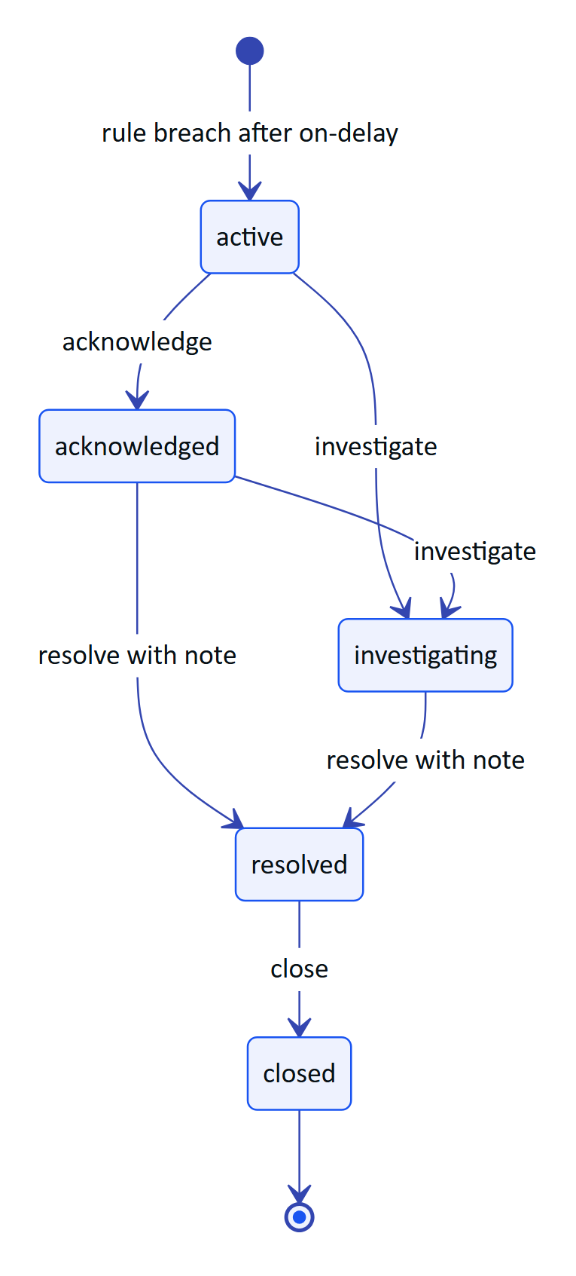
Figure 10. Alarm event lifecycle (alarm_state); cleared_at records the measured condition independently
Table 50. Alarm transitions, permissions and side effects
Action | From | To | Permission | Side effects
(engine) trigger | none | active | alarm engine | Insert alarm_events, history triggered, audit_events alarm.triggered.
(engine) clear | open states | unchanged | alarm engine | Set cleared_at; history condition_cleared.
acknowledge | active | acknowledged | alarm.acknowledge | Set acknowledged_by/at.
investigate | active, acknowledged | investigating | alarm.investigate
resolve | acknowledged, investigating | resolved | alarm.resolve | Note required, stored in resolution_note.
close | resolved | closed | alarm.close | Set closed_by/at.

While an alarm is open and not cleared, a worse value updates peak_value. A new alarm for the same rule is only raised after the previous one has cleared.

7.2 Inspections
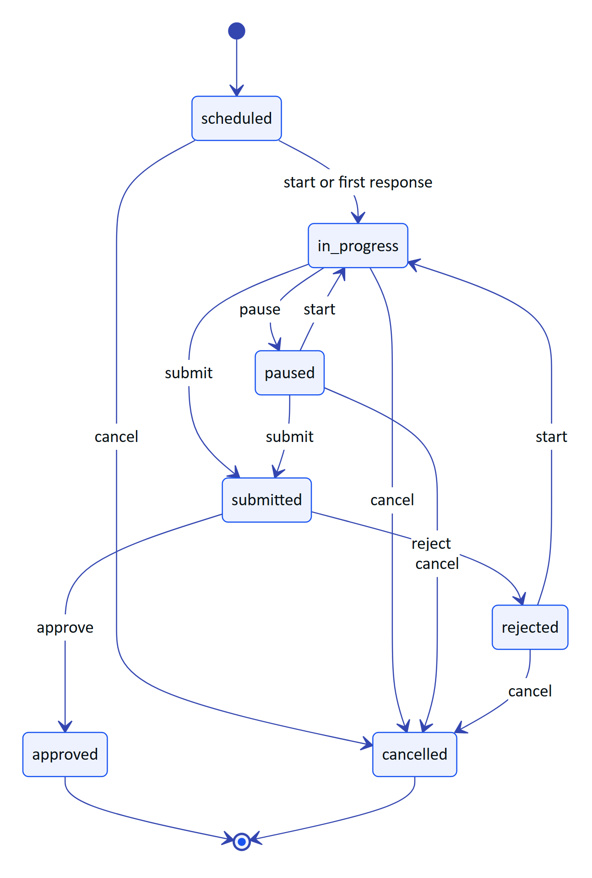
Figure 11. Inspection lifecycle (inspection_status) from INSPECTION_TRANSITIONS
Responses are accepted in scheduled, in_progress, paused and rejected (INSPECTION_EDITABLE). Every state change increments revision; a client that sends a stale expectedRevision receives revision_conflict. The UI labels rejected as "Returned".

7.3 Maintenance tasks
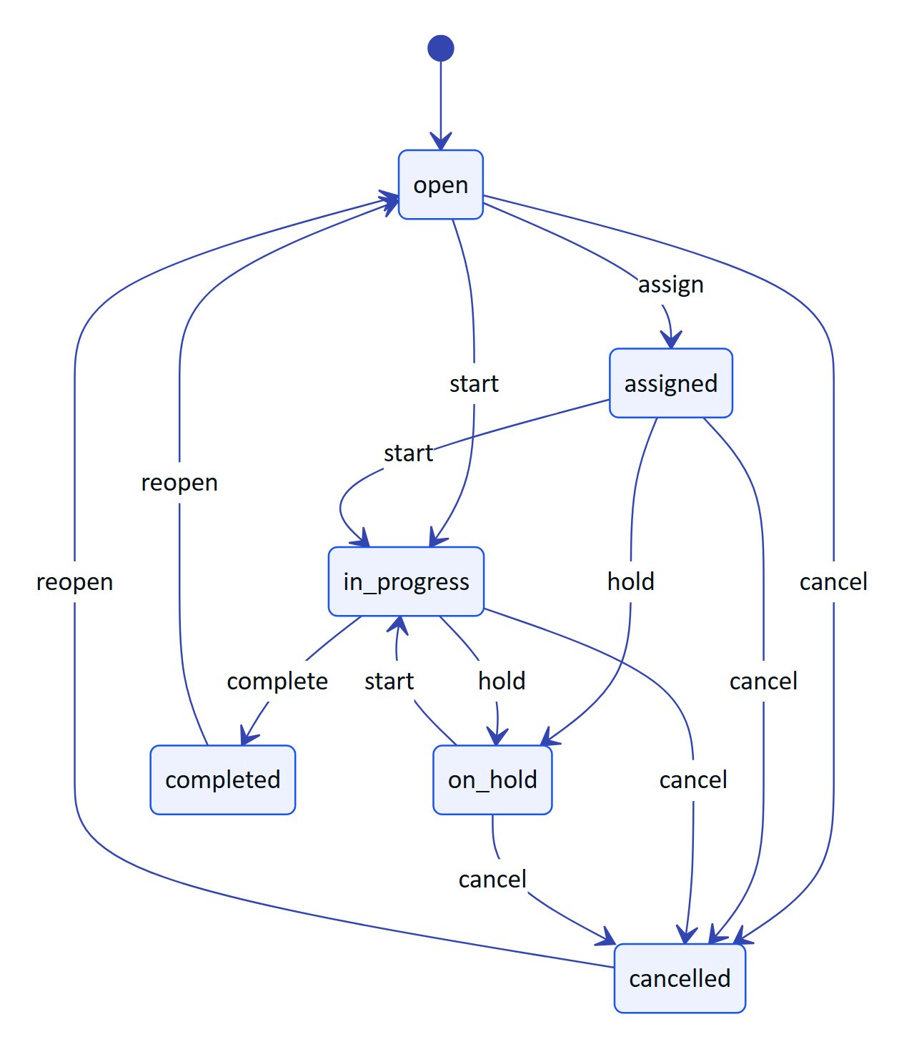
Figure 12. Maintenance task lifecycle (maintenance_status) from MAINTENANCE_TRANSITIONS

7.4 Audit documents
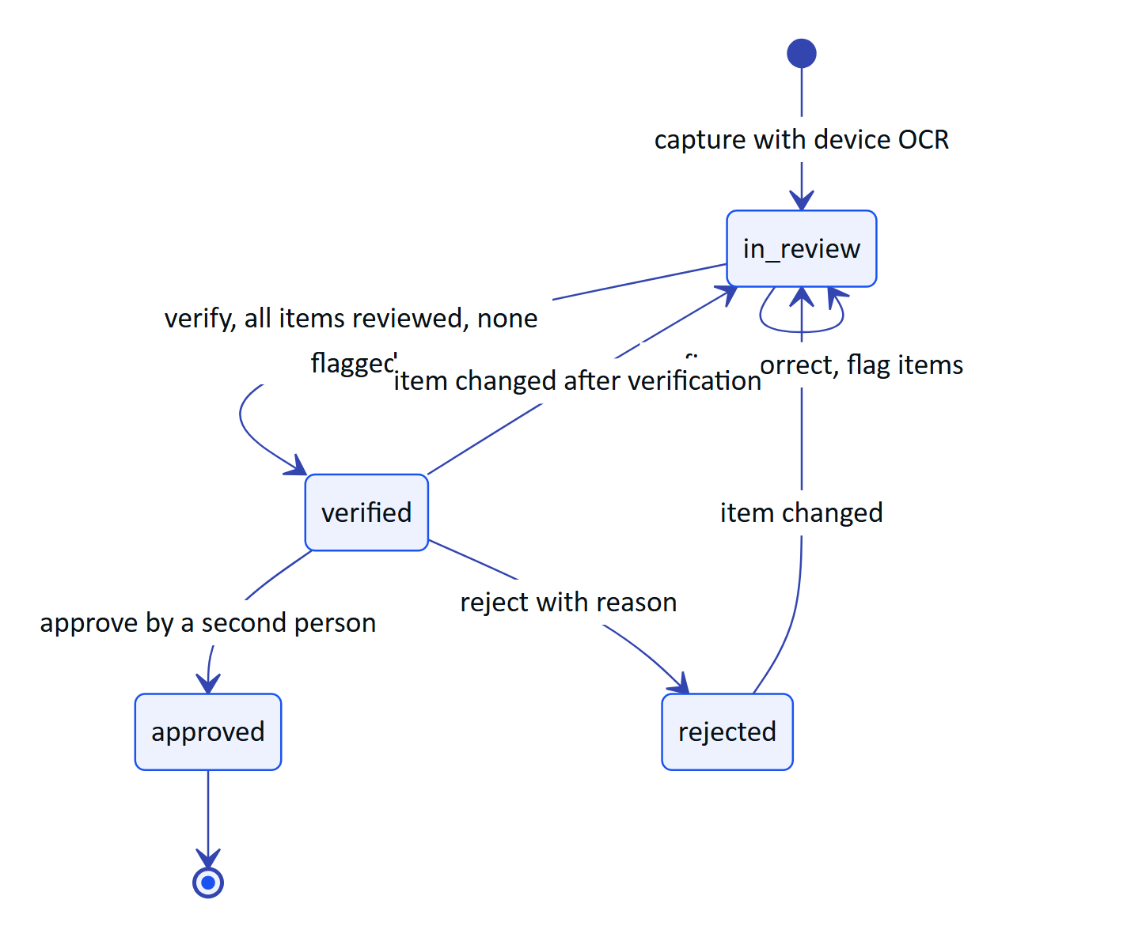
Figure 13. Audit document review lifecycle (audit_doc_status); processing is reserved and not yet written
Table 51. Audit document rules enforced in apps/api/src/modules/audit-docs.ts
Rule | Enforcement
Capture starts in in_review | Insert sets status = 'in_review'. processing exists in the enum and the list filter but is never written.
Vision refinement only before review starts | enhance returns review_started once any item is confirmed or corrected.
Verification needs a complete review | reviewProgress() must report no pending and no flagged items.
Verification and approval are console actions | Device principals receive forbidden.
Four-eyes approval | approved_by must differ from verified_by, except in demo tenants (recorded as self-approved in the event note).
Approved documents are locked | Item edits and renames return locked.
Editing after verification reopens the review | Status returns to in_review; verifier and approver fields are cleared; event review.reopened.
Concurrent edits | Every update matches on revision and increments it; a mismatch returns stale.

7.5 Pairing challenges and devices
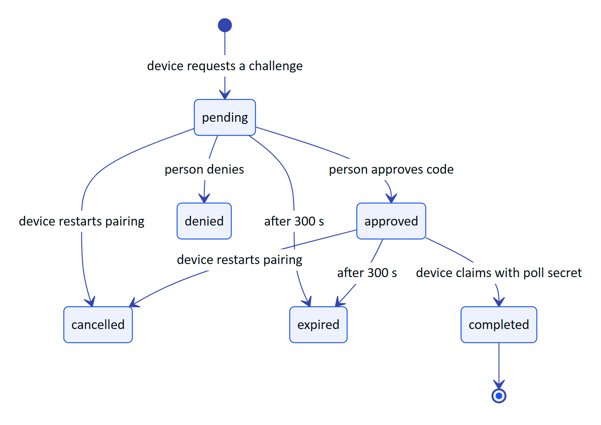
Figure 14. Pairing challenge lifecycle (pairing_status), modelled on the OAuth device authorization grant
devices.status has only three stored values (active, suspended, revoked). The console shows a richer composite state computed by deriveDeviceState() in packages/domain/src/devices.ts:
Table 52. Composite device state derived from stored columns
Displayed state | Derived from
revoked | status = 'revoked'
suspended | status = 'suspended'
connected | active, current assignment, and an open stream or last_seen_at within 90 s
paired | active, no current assignment
assigned | active, assigned, never seen
disconnected | active, assigned, last seen more than 90 s ago
unregistered, pending_pairing | client-side states before a devices row exists

8 Tenancy and row-level security

8.1 How organization context is set
Every request runs in a database transaction that first drops to the role hydris_app and then sets a transaction-local setting. withTenant() sets app.org_id; withSystem() sets app.bypass = 'on' for the few operations that legitimately span tenants. Both use set_config(..., true) and SET LOCAL, so the context ends with the transaction and cannot leak to the next request on a pooled connection.
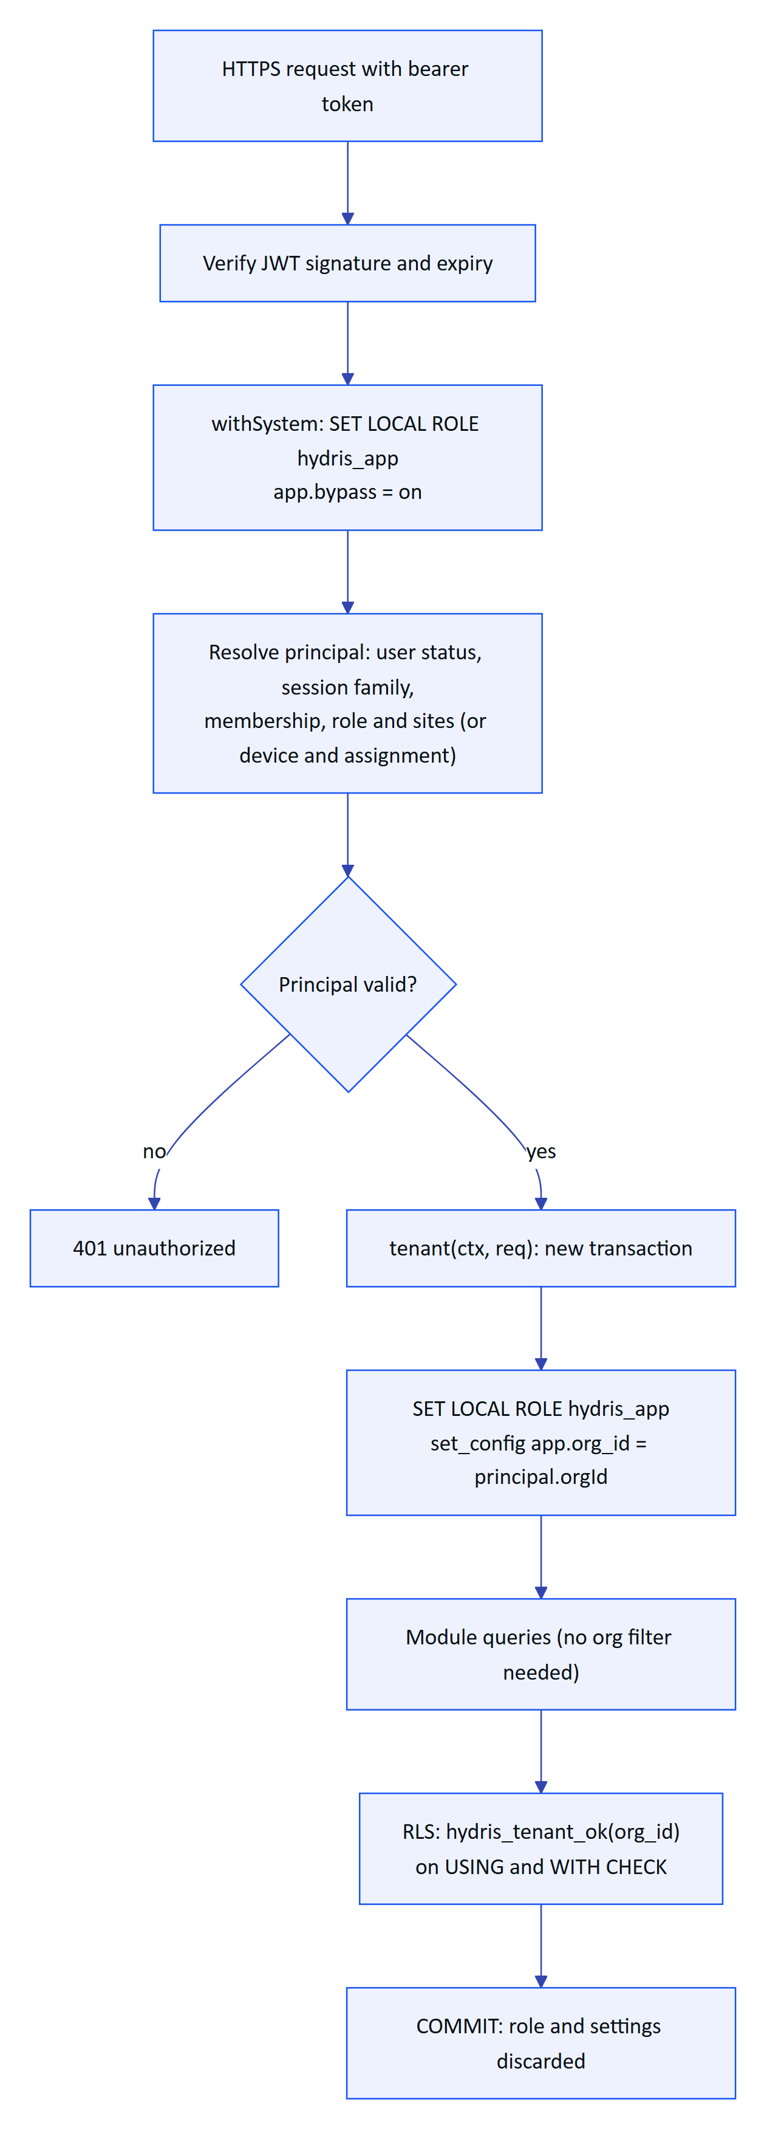
Figure 15. How the organization context is set for each API request
The policy function from 0001_rls.sql:
CREATE OR REPLACE FUNCTION hydris_tenant_ok(row_org uuid) RETURNS boolean
LANGUAGE sql STABLE AS $$
SELECT current_setting('app.bypass', true) = 'on'
OR row_org = nullif(current_setting('app.org_id', true), '')::uuid
$$;
If neither setting is present, current_setting(..., true) returns null, the comparison is null, and the row is invisible. A request that forgets to set context therefore sees nothing rather than everything. FORCE ROW LEVEL SECURITY makes the policy apply to the table owner as well.

8.2 Policy inventory
Table 53. Row-level security and grants per table
Policy or grant | Tables | Migration
tenant_isolation on org_id | memberships, membership_sites, invitations, sites, facilities, process_areas, assets, gateways, sensors, telemetry_readings, alarm_rules, alarm_events, alarm_event_history, documents, inspection_templates, inspection_routes, inspections, inspection_responses, attachments, maintenance_tasks, maintenance_activity, devices, device_assignments, device_sessions, notifications, audit_events, simulation_runs | 0001
tenant_isolation on id | organizations | 0001
tenant_isolation on org_id | telemetry_corrections, ui_profiles, ui_profile_versions, ui_profile_assignments | 0003
system_only (app.bypass = 'on') | realtime_events | 0006
tenant_isolation on org_id | audit_documents, audit_document_pages, audit_document_events | 0008
No RLS, system context only | users, auth_sessions, auth_tokens, mail_outbox, pairing_challenges, inquiries | n/a
UPDATE and DELETE revoked from hydris_app | audit_events (0001), telemetry_corrections (0003) | 0001, 0003
SELECT and INSERT only for hydris_app | audit_document_events | 0008
SELECT, INSERT, DELETE only | realtime_events | 0006

Because withSystem() also runs as hydris_app, the append-only grants hold even for background jobs: no code path in the application can rewrite the audit trail.
WARNING
Superuser and owner connections bypass RLS. Production must connect as a role that is a member of hydris_app with SET rights (0004_app_role_membership.sql and 0006_realtime_events_rls.sql grant this on PG16+ managed Postgres). Ad hoc SQL consoles connected as the owner see every tenant.

8.3 Checklist for a new tenant table
- Add orgId: orgRef() as a column in schema.ts.
- Generate the table migration with drizzle-kit generate.
- Write a second, hand-written migration that grants hydris_app the needed privileges, enables and forces RLS, and creates tenant_isolation with hydris_tenant_ok(org_id) (copy 0008_audit_documents_rls.sql).
- Revoke UPDATE and DELETE if the table is a log.
- Add a test that reads the table from a second organization and expects zero rows.

8.4 Site scoping
RLS isolates organizations, not sites. Site restrictions (memberships.all_sites = false plus membership_sites) are enforced in application code by requireSite(), siteScope() and scopedRow() in apps/api/src/core and the modules. This is Built but not defended in depth by the database.
DECISION
Site scoping stays in the application for now: it changes per request and per role, and expressing it in policies would need a per-request site list in a setting. A Planned option is an app.site_ids setting and a second policy on site-bearing tables for the most sensitive data (telemetry, audit documents).

9 Module access patterns
Table 54. Which modules read and write which tables
Module | Writes | Reads | Context
auth.ts | users, auth_sessions, auth_tokens, memberships, membership_sites, mail_outbox (via sendMail) | users, memberships, organizations | system for sign-in, tenant for org switching
org.ts | memberships, membership_sites, invitations, organizations | audit_events, users | tenant
plant.ts | sites, facilities, process_areas, assets, gateways, sensors, documents, attachments | all plant tables | tenant
telemetry.ts | telemetry_readings, sensors (latest value), telemetry_corrections, gateways (last_seen_at) | sensors, readings, corrections | system to resolve gateway keys, then tenant
alarms.ts | alarm_rules, alarm_events, alarm_event_history | rules, events, sensors | tenant; system for stale-rule jobs
inspections.ts | inspections, inspection_responses, maintenance_tasks (follow-ups), notifications | templates, routes, assets | tenant
maintenance.ts | maintenance_tasks, maintenance_activity | tasks, assets | tenant
devices.ts | pairing_challenges, devices, device_assignments, device_sessions | memberships, sites | system for pairing, tenant for management
ui-profiles.ts | ui_profiles, ui_profile_versions, ui_profile_assignments | same | tenant
audit-docs.ts | audit_documents, audit_document_pages, audit_document_events | same, sites, users | tenant; system for demo hydration
insights.ts | none | documents (full text), assets, sensors, users, alarms, inspections | tenant
voice-assistant.ts | none | sensors, alarms, inspections, tasks, documents | tenant
simulation.ts | simulation_runs, telemetry (through ingest), maintenance_tasks, assets | scenarios | tenant
public.ts | inquiries | none | system
core/services.ts | audit_events, notifications, mail_outbox | none | caller's transaction
core/events.ts, realtime.ts | realtime_events | realtime_events | system
jobs.ts | pairing_challenges (expire), alarm tables (stale), realtime_events (prune) | simulation_runs | system

10 Indexing and query patterns
The 71 indexes are all B-tree. They follow the main read paths of the console and glasses:
Table 55. Main query patterns and the indexes that serve them
Query pattern | Example route or code | Index
Latest values per site | overview, glasses measurements | sensors_site_idx plus cached sensors.last_* (no time-series scan)
Sensor history for a range | GET /sensors/:id/history with date_bin buckets | telemetry_sensor_ts_uq and telemetry_sensor_ts_idx
Idempotent ingest | INSERT ... ON CONFLICT (sensor_id, ts) DO NOTHING | telemetry_sensor_ts_uq
Effective value with corrections | effectiveReadings() lateral join, newest correction first | telemetry_corrections_reading_idx
Open alarms for an org | alarm list, overview counters | alarm_events_org_state_idx
Open alarm for a rule during evaluation | evaluateSensor() | alarm_events_rule_idx
My inspections and tasks | glasses home, mobile work tab | inspections_assignee_idx, maintenance_assignee_idx
Latest response per step | inspection view | inspection_responses_step_idx
Unread notifications | bell counter | notifications_user_idx
Audit log by time or by entity | console audit view, entity history | audit_org_at_idx, audit_entity_idx
Realtime replay since cursor | SSE id > lastEventId | primary key on realtime_events.id
Token lookups | refresh, invite, reset, device refresh, gateway key | unique token_hash, key_hash, code_hash indexes

Known gaps, all Planned:
- Full-text search on documents computes to_tsvector('english', title || ' ' || body) on every query (insights.ts). Add a generated tsvector column with a GIN index once a tenant holds more than a few hundred documents.
- audit_document_pages has no org_id index; reads go through document_id, which is covered by the unique index, so this is acceptable.
- Telemetry at scale needs time partitioning (monthly) or TimescaleDB hypertables, plus BRIN on ts for archive partitions. See "Volumes and growth".
- telemetry_org_ts_idx serves organization-wide time scans (exports, reports). It costs one index entry per reading; review it once reports move to rollup tables.
TIP
RLS adds hydris_tenant_ok(org_id) to every scan. Indexes that lead with org_id (sites, assets, sensors, alarm events, inspections, maintenance, audit) let the planner combine the policy and the filter in one index range. Lead with org_id for new tenant indexes unless the first column is already tenant-unique.

11 Data quality rules
Data quality is enforced at three points: ingestion, the review workflows, and display. All rules below are Built unless marked otherwise.

11.1 Telemetry ingestion
ingest() in apps/api/src/modules/telemetry.ts validates every reading before storage and returns a per-item rejection reason. Accepted gateway batches hold up to 500 readings.
Table 56. Telemetry ingestion checks and rejection reasons
Check | Rule | Rejection reason
Synthetic isolation | source = 'simulator' only for is_demo organizations; also enforced by CHECK on synthetic | synthetic_not_allowed
Sensor exists in the organization, not archived | lookup by id within the tenant | unknown_sensor
Sensor enabled | sensors.enabled | sensor_disabled
Gateway site | a gateway may only write sensors on its own site | sensor_not_on_gateway_site
Clock skew | ts at most 5 minutes in the future | timestamp_in_future
Late data | ts at most 30 days old, except lab | timestamp_too_old
Finite value | not NaN or infinite | not_finite
Known unit | canonical or a listed alternative unit | unknown_unit
Physical plausibility | value within validRange after conversion | out_of_range
Duplicate | same (sensor_id, ts) | counted as duplicate, not an error

Table 57. Physical plausibility ranges in canonical units (MEASURAND_DEFS)
Measurand | Unit | Valid range | Typical band
ph | pH | 0 to 14 | 6.5 to 8.5
temperature | °C | -20 to 120 | 10 to 35
dissolved_oxygen | mg/L | 0 to 25 | 1.5 to 3
turbidity | NTU | 0 to 4,000 | 0 to 10
conductivity | µS/cm | 0 to 200,000 | 200 to 3,000
flow_rate | m³/h | 0 to 100,000 | none
tank_level | % | 0 to 100 | 20 to 80
pressure | bar | -1 to 100 | none
motor_current | A | 0 to 2,000 | none
vibration | mm/s | 0 to 100 | 0 to 4.5
runtime_hours | h | 0 to 1,000,000 | none
tss | mg/L | 0 to 50,000 | none
cod | mg/L | 0 to 100,000 | none
bod | mg/L | 0 to 50,000 | none
ammonia | mg/L | 0 to 2,000 | 0 to 5
residual_chlorine | mg/L | 0 to 20 | 0.2 to 1

Out-of-order readings are stored for history but do not overwrite a newer cached latest value or re-trigger alarms. Readings with quality bad are stored but never evaluated against alarm rules.

11.2 Freshness
freshness() classifies the age of sensors.last_ts relative to expected_interval_s: live up to 2 times the interval, delayed up to 5 times, stale beyond, and no_data without a timestamp. Stale values must be visibly marked and are excluded from health roll-ups. Stale alarm rules (condition = 'stale') are evaluated by a background job every 30 seconds on the long-running server, or per cron pass on serverless.

11.3 Corrections
A correction needs a reason of at least 5 characters, the corrected value is normalised and range-checked like an ingested reading, and the original reading row is never modified. The newest correction per reading defines the effective value; invalidate excludes the reading from charts, aggregates and the cached latest value (recomputeLatest()). CSV exports show original value, effective value, status, reason, author and time.

11.4 Inspections
Readings outside expectedMin/expectedMax and abnormal options set outcome = 'abnormal'. Response timestamps more than 5 minutes in the future and values whose kind does not match the step are rejected as conflicts.

11.5 Audit documents
Table 58. Audit document quality rules (packages/domain/src/auditdoc.ts)
Rule | Behaviour
Plausibility ranges | pH 0 to 14; dissolved oxygen 0 to 25 mg/L; temperature -20 to 120; percentages 0 to 100; turbidity 0 to 4,000 NTU. Out-of-range fields get confidence capped at 0.4 and a note.
Table cell checks | Numeric cells are range-checked against the row label; when a labelled field with the same digits passes, it is offered as a suggestion (catches a dropped decimal point).
Engine agreement | Numbers must match exactly after folding look-alike characters (O to 0, l to 1, S to 5); text may differ slightly (close at similarity 0.85 or more).
Needs attention | mismatch or confidence below 0.75 is shown to the reviewer first.
Bulk confirm | Only pending fields with more than one source, match agreement and confidence of at least 0.8.
Low-quality capture | A page with OCR confidence below 60 adds a warning to rescan.

RISK
Two engines can agree on a wrong value. Plausibility checks cover the common water-quality parameters only; COD, BOD and flow values in scanned sheets are not range-checked. Planned: reuse MEASURAND_DEFS.validRange for field labels that map to a measurand.

12 Data lifecycle and retention

12.1 Current behaviour
Only one table is pruned today: realtime_events, older than one day, by pruneRealtimeEvents() (hourly on the long-running server in db mode, each cron pass on serverless). Pairing challenges are marked expired every minute but not deleted. Everything else is kept indefinitely. Deleting an organization cascades to every tenant row.

12.2 Recommended policy
Retention should be configurable per organization, with defaults that meet typical record-keeping obligations for effluent and sewage treatment. The periods below are proposals, not legal advice; confirm each against the customer's consent-to-operate conditions and applicable law before enforcement.
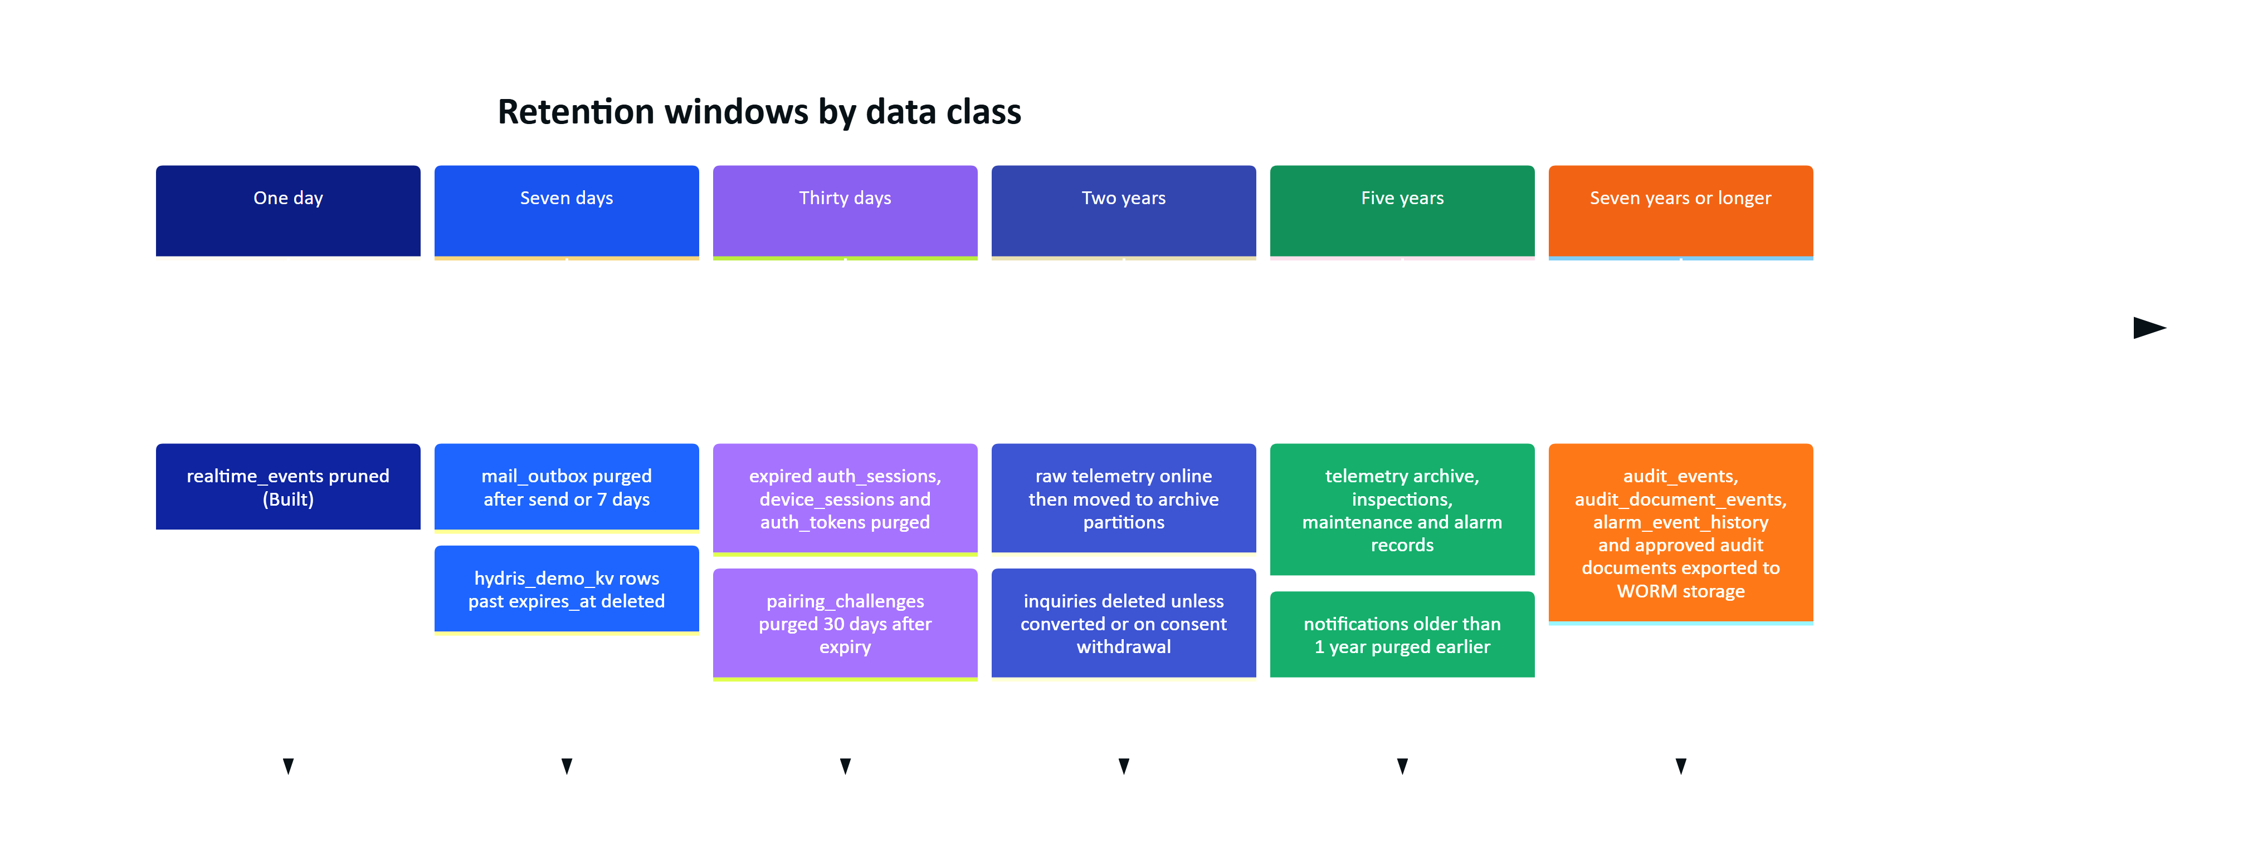
Figure 16. Recommended data lifecycle by age (Planned, except where marked Built)
Table 59. Retention by table, current and recommended
Data | Current | Recommended (Planned)
realtime_events | Pruned after 1 day (Built) | Keep.
telemetry_readings | Indefinite | 2 years online in monthly partitions, then archive (cold storage or compressed partitions) for at least 5 years; keep hourly rollups online.
telemetry_corrections | Indefinite | Same as the readings they correct.
alarm_events, alarm_event_history | Indefinite | At least 5 years; history follows its event.
inspections, inspection_responses, maintenance_* | Indefinite | At least 5 years, configurable.
audit_documents, audit_document_pages | Indefinite, images in Postgres | Approved records for the customer's record period (at least 5 years); page images in object storage with lifecycle rules; rejected scans 1 year.
audit_events, audit_document_events | Indefinite, append-only | At least 7 years, then export to WORM storage before deletion.
notifications | Indefinite | Read notifications 1 year.
auth_sessions, device_sessions, auth_tokens | Expired rows remain | Purge 30 days after expiry or revocation.
pairing_challenges | Expired rows remain | Purge 30 days after expiry.
invitations | Indefinite | Purge 90 days after expiry, acceptance or revocation.
mail_outbox | Indefinite, contains live links | Purge after send or 7 days.
inquiries | Indefinite | 24 months, or on consent withdrawal (DPDP Act 2023, GDPR).
simulation_runs | Indefinite | 90 days after stop.
hydris_demo_kv | Expired rows ignored, never deleted | Delete rows past expires_at daily.

IMPORTANT
Retention jobs must run in system context as hydris_app. Because UPDATE and DELETE are revoked on the audit logs, purging them needs a dedicated maintenance role and a documented, audited procedure. That is intentional.

13 Volumes and growth

13.1 Telemetry
Telemetry dominates storage. Rows per day per sensor follow directly from the reporting interval:
Table 60. Telemetry rows per sensor by reporting interval
Interval | Rows per sensor per day | Rows per sensor per year | Typical use
5 s | 17,280 | 6.3 million | Demo simulator (SIM_STEP_SECONDS = 5)
10 s | 8,640 | 3.2 million | Fast online analysers
60 s | 1,440 | 525,600 | Default expected_interval_s
300 s | 288 | 105,120 | Slow process values
1 day | 1 | 365 | Lab parameters (COD, BOD, TSS)

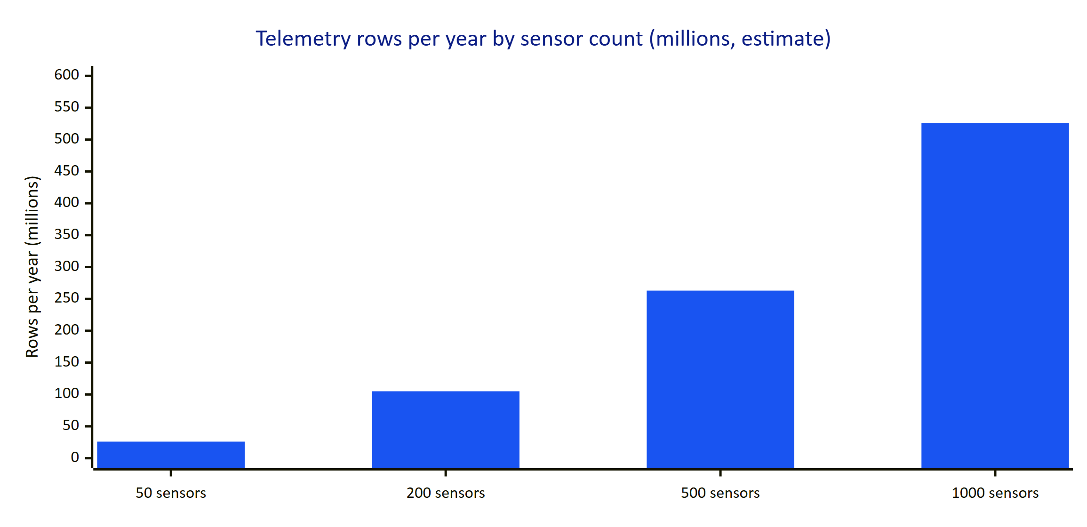
Figure 17. Estimated telemetry rows per year at the default 60 s interval (estimate, not measured)
Storage estimate: a reading row is about 100 to 130 bytes of heap (tuple header, bigint, two uuid, two timestamptz, double, two enums, boolean and a short message_id), plus about 40 to 50 bytes in each of the three indexes. Roughly 250 bytes per reading in total is a reasonable planning figure (estimate). At 60 s that is about 130 MB per sensor-year, so a 200-sensor plant adds about 26 GB per year and 1,000 sensors about 130 GB per year. Dropping message_id for gateways that do not need it and moving cold months to compressed partitions are the main levers.
RISK
A single unpartitioned telemetry_readings table will slow down vacuum, index maintenance and range scans beyond a few hundred million rows. Partition by month before the first customer passes about 200 sensors at 60 s.

13.2 Other tables
Table 61. Growth estimates for one mid-size site (estimate, not measured)
Table | Driver | Estimate per site per year
alarm_events and history | 5 to 20 alarms a day, 3 to 5 history rows each | 2,000 to 7,000 events; 10,000 to 35,000 history rows
inspections, inspection_responses | 10 to 30 inspections a day, 5 to 10 steps | 4,000 to 11,000 inspections; 20,000 to 110,000 responses
maintenance_tasks | 2 to 10 a day | 700 to 3,700
audit_events | every write action | 50,000 to 200,000
realtime_events | every published event, pruned daily | bounded at about one day of events
audit_documents and pages | 5 to 20 scans a day, 1 to 3 pages | 2,000 to 7,000 documents; 0.6 to 4 GB of base64 page data in Postgres

13.3 Demo tenant
The showcase seed produces a known volume, useful for performance tests: 27 simulated signals at 10-minute resolution over 7 days (27 × 1,008 = 27,216 readings), 30 lab readings, 2 sites, 15 assets and 30 sensors.

14 Binary and image storage
Two storage paths exist today:
- Attachments (attachments) store only metadata in Postgres. Bytes go to local disk (STORAGE_DIR) or a private Vercel Blob store (attachments/<org>/<uuid>) through createStorage() in apps/api/src/core/services.ts. Files are only served through the authorised /api/attachments/:id route. Built.
- Audit page images (audit_document_pages.data) are stored as base64 text inside Postgres, together with the OCR JSON. The device downscales scans (the schema comment targets about 600 KB) and the API rejects pages over 900 KB decoded and documents over 6 pages. Built.
RISK
Base64 in Postgres costs about 37 % more space than the binary, is mostly incompressible (JPEG), inflates backups and logical replication, and every SELECT * on pages drags megabytes through the pool. A six-page document can approach 7 MB of row data. In demo mode, the same snapshot is also copied into hydris_demo_kv.

14.1 Proposed migration to object storage
Planned. Move page images to the same storage adapter as attachments and keep only a reference in Postgres.
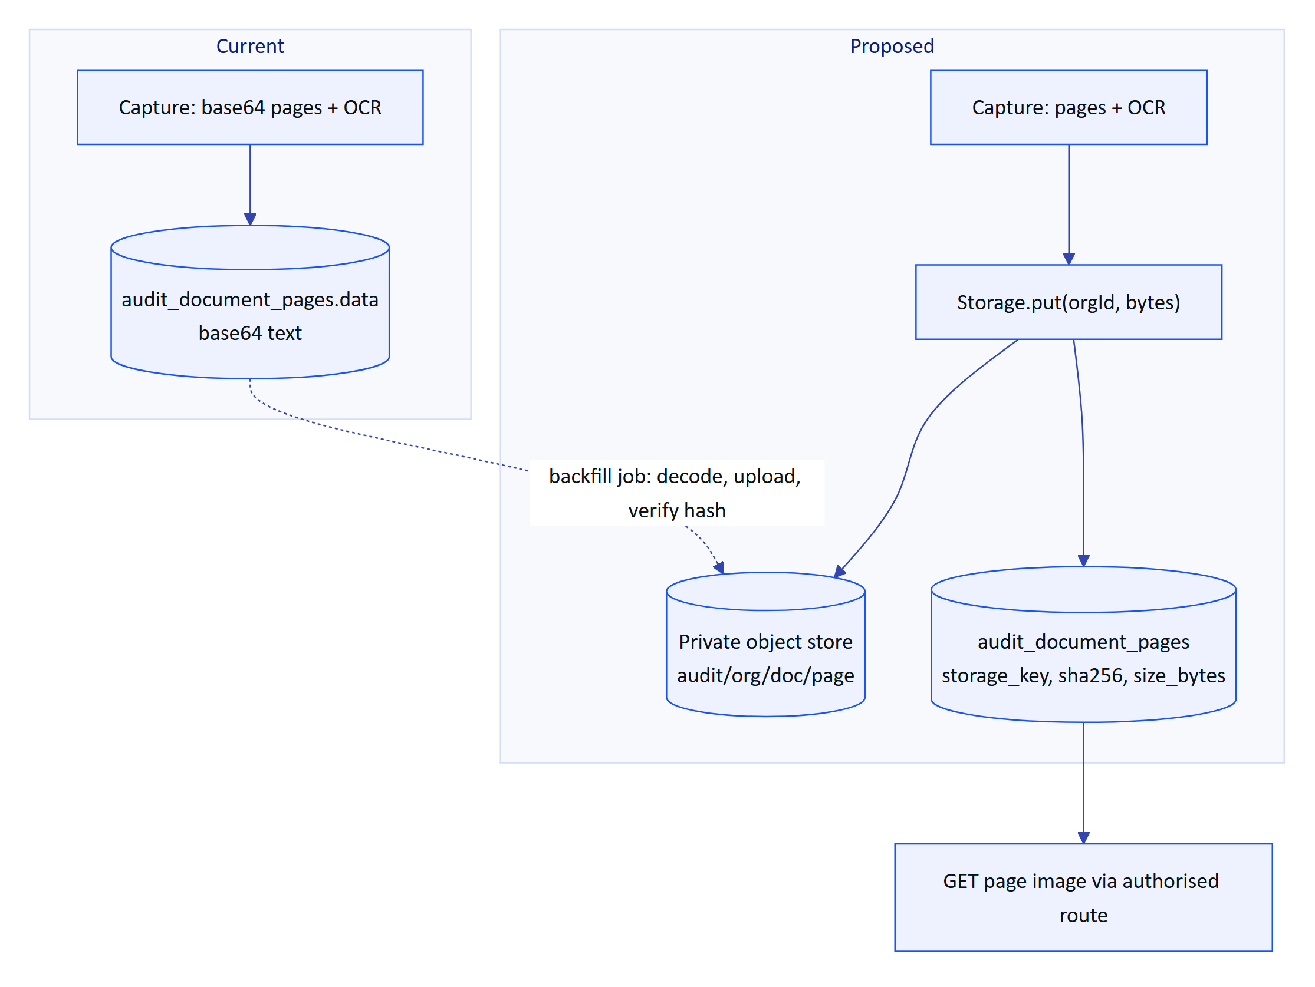
Figure 18. Proposed migration of audit page images from Postgres to object storage (Planned)
Migration steps:
- Add nullable columns storage_key text, sha256 text and size_bytes integer to audit_document_pages; make data nullable.
- Write new captures to object storage; keep ocr in Postgres (it is queried during review and vision merge).
- Backfill existing rows in batches in system context: decode, upload, record hash and key, verify by re-reading, then set data to null.
- Serve images through an authorised route that checks tenancy and site scope, like attachments.
- After a full release cycle with no reads of data, drop the column and VACUUM FULL (or repack) the table.
- Apply bucket lifecycle rules that mirror the record retention policy, with object lock for approved records.

15 Migrations

15.1 Process
Schema changes start in apps/api/src/db/schema.ts. npm run db:generate (Drizzle Kit, config in apps/api/drizzle.config.ts) writes a numbered SQL file and a snapshot into apps/api/drizzle/. Policy, grant and role changes are hand-written migrations in the same folder, registered in meta/_journal.json. npm run db:migrate applies pending migrations; the API also migrates on start-up.
On Postgres, createDatabase().migrate() in apps/api/src/db/client.ts takes a session-level advisory lock (pg_advisory_lock(4872917633)) on one dedicated connection, so several cold-starting serverless instances never migrate concurrently. PGlite (tests, demo) migrates in process.
Table 62. Migration history
Migration | Kind | Content
0000_init | generated | 22 enums, 34 tables, foreign keys, indexes, 2 CHECK constraints
0001_rls | hand-written | hydris_app role, grants, hydris_tenant_ok(), RLS on 27 tenant tables and organizations, audit_events append-only
0002_corrections_ui_profiles | generated | telemetry_corrections, ui_profiles, ui_profile_versions, ui_profile_assignments
0003_rls_new_tables | hand-written | Grants and RLS for the four new tables; corrections append-only
0004_app_role_membership | hand-written | Grant hydris_app to the migrating user (WITH SET TRUE on PG16+)
0005_realtime_events | generated | realtime_events
0006_realtime_events_rls | hand-written | system_only policy; re-check SET capability on PG16+
0007_audit_documents | generated | audit_doc_status enum, audit_documents, pages, events
0008_audit_documents_rls | hand-written | Grants (events insert-only) and RLS for audit tables

15.2 Rules for schema changes
- Expand, then contract. Add nullable columns or new tables first, deploy code that writes both shapes, backfill, then remove the old shape in a later release. Serverless instances of two versions run side by side during a deploy.
- No destructive change in a generated migration without review. Drizzle Kit can emit DROP COLUMN; a reviewer must confirm a backfill exists.
- Every new tenant table gets an RLS migration (see the checklist above). Tests run on PGlite with the same migrations, so a missing policy fails the cross-tenant test.
- Enum values are append-only. Renaming or removing a value needs a new type and a data migration.
- Large tables (telemetry_readings, audit_events) need CREATE INDEX CONCURRENTLY in a hand-written migration outside a transaction once they are big.

16 Seed and demo data
Table 63. Seed entry points
Entry point | What it creates | Used by
npm run seed (apps/api/src/seed/cli.ts) | Platform admin from SEED_ADMIN_EMAIL and SEED_ADMIN_PASSWORD (12+ characters) | New environments
npm run seed -- --demo | Plus the Riverbend demo tenant with 7 role accounts at @demo.hydris.local (password SEED_DEMO_PASSWORD) | Staging, sales environments
seedDemoShowcase() (seed/showcase.ts) via bootDemo() | Full showcase tenant on every instance in demo mode | Public demo, tests

The demo tenant is the organization Riverbend Process Industries (Demo) (slug riverbend-demo, is_demo = true, time zone Asia/Kolkata). Every row has a deterministic UUID v5 from demoId() in seed/ids.ts, so separate in-memory databases on separate serverless instances agree on every identifier.
Table 64. Demo showcase content
Area | Content
Sites | Riverbend Industrial Park (RIP, ETP-01, 3,000 m³/day, 5 process areas) and Riverbend Township STP (RTS, STP-02, 5,000 m³/day, 4 process areas)
Assets and sensors | 7 + 8 assets; 15 + 12 continuous sensors and 3 lab sensors (COD, BOD, TSS)
Telemetry | 7 days at 10-minute resolution for 27 signals, source = 'simulator', synthetic = true; 10 lab samples per lab parameter over 14 days, source = 'lab', including one COD exceedance (262 mg/L)
Rules and alarms | Threshold rules from SIM_PLANT.thresholds, two stale rules, alarm events across all states with history
Documents | Approved SOPs and a lockout/tagout safety notice, linked to rules as procedures
Work | 5 inspection templates, routes, inspections in several states with responses, maintenance tasks with activity
Devices | 5 devices: two active hardware glasses, a browser simulator, one suspended and one revoked unit
UI profiles | Profiles with published, superseded and draft versions and assignments at several scopes
People and trail | Owner account, role accounts, notifications and audit events

Live data in demo mode comes from DemoTicker (apps/api/src/demo.ts): at most every 5 seconds a request advances running simulations and feeds the second site's instruments through the normal ingest() path, so alarms and realtime events behave exactly as with a gateway.
IMPORTANT
Synthetic data is labelled at every level: organizations.is_demo, telemetry_readings.synthetic (tied to source by a CHECK constraint), and synthetic flags on alarms, inspections and maintenance tasks. Ingestion rejects simulator data for customer tenants. Analytics must filter on these flags.

17 Privacy classification
Each table is classified by the most sensitive data it holds. PII means personal data about an identifiable person; Secret means credentials or material that grants access; Sensitive means business or compliance data a customer would treat as confidential; Operational means plant data without personal content.
Table 65. Privacy classification per table
Table | Class | Personal or sensitive fields | Notes
users | PII, Secret | email, name, password_hash, mfa_secret_enc, last_login_at | Global; erasure must keep audit references (actor ids have no FK).
memberships, membership_sites | PII | role, title
invitations | PII, Secret | email, name, token_hash
auth_sessions | PII, Secret | ip, user_agent, token_hash
auth_tokens | Secret | token_hash
mail_outbox | PII, Secret | recipient, body with live links | Purge (Planned).
inquiries | PII | name, email, phone, company, job_title, message | Consent recorded; IP hashed.
devices | PII (indirect) | last_ip, hardware_id, link to wearer
device_assignments | PII | who wore which device when | Workforce monitoring sensitivity.
device_sessions, pairing_challenges | Secret | token, code and poll-secret hashes, requester_ip
notifications | PII | per-person content
audit_events | PII, Sensitive | actor ids, ip, metadata | Legal record.
alarm_event_history, maintenance_activity | PII | actor ids, notes
inspections, inspection_responses | PII, Sensitive | assignee, recorded_by, notes, photos via attachments
attachments | PII possible | photos may show people | Bytes in object storage.
audit_documents, audit_document_pages, audit_document_events | Sensitive, PII possible | scanned names and signatures, compliance values | Page images may contain handwriting and signatures.
telemetry_readings, telemetry_corrections | Sensitive | discharge quality values | Compliance evidence; corrected_by is PII.
alarm_rules, alarm_events | Sensitive | limits and exceedances | assigned_to and actor columns are PII.
documents | Sensitive | procedures
organizations, sites, facilities, process_areas, assets, gateways, sensors | Operational | site coordinates, gateway key hashes | gateways.key_hash is Secret.
ui_profiles, ui_profile_versions, ui_profile_assignments | Operational |  | User and device scope rows are PII by link.
realtime_events | Sensitive, transient | payloads | Pruned after 1 day.
simulation_runs, hydris_demo_kv | Operational | demo only

NOTE
Hydris processes field workers' personal data as a processor for its customers. Data subject requests (access, correction, erasure) are handled per organization; a user erasure should anonymise users and keep the trail rows whose actor ids no longer resolve to a name. The full control mapping is in the Security and Privacy document (HFG-SEC).

18 Mobile and client-side data

18.1 Android app
The native Android app (apps/android) keeps no local database. Screens load from the API on demand. The only persisted data is credentials in SecureStore (data/SecureStore.kt): an encrypted key/value store on top of SharedPreferences file hydris.secure.
Table 66. Android SecureStore entries
Key | Content | Written by
cookies | Session cookies for the API (refresh cookie), one per line | HydrisApi cookie jar
device.access | Glasses device access token | Pairing, device refresh
device.refresh | Glasses device refresh token (30 days) | Pairing, device refresh
device.id, device.name | Paired device identity | Pairing

Each value is encrypted with AES-256-GCM using a non-exportable Android Keystore key (alias hydris.secure.v1); the stored string is Base64 of a 12-byte IV followed by ciphertext and a 128-bit tag. Nothing secret reaches SharedPreferences in plain text. Scanned pages are held in memory until upload, then sent as base64 with their OCR readings (ScanUpload in data/Models.kt, source = "mobile"). The Kotlin models mirror the API responses and ignore unknown keys, so the server can add fields without breaking the app.

18.2 Web glasses app
The browser-based glasses app (apps/web/src/glasses) is offline-first for inspections and stores in localStorage:
Table 67. Web glasses app local storage
Key | Content
hydris.glasses.hw | Install identifier used as hardware_id at pairing
hydris.glasses.refresh | Device refresh token
hydris.glasses.queue | Offline queue of inspection responses { inspectionId, op: { opId, stepId, value, note, recordedAt } }
hydris.glasses.cache.ctx, hydris.glasses.cache.docs, hydris.glasses.cache.doc.<id> | Last good context and SOPs with a timestamp, shown as stale when offline

Queued operations replay idempotently because opId becomes client_op_id and the server ignores duplicates.
RISK
localStorage is readable by any script on the origin. A device refresh token there is acceptable for the browser simulator but not for production hardware; link.ts defines a SecureStore interface so a native runtime can supply hardware-backed storage. Planned for production glasses runtimes.

19 Analytics and event model
Planned. There is no analytics pipeline today. Product and operational analytics are currently answered from the transactional tables and audit_events. The proposal below keeps analytics out of the request path and reuses events the API already produces.

19.1 Principles
- Analytics read from a replica or an export, never from the primary during business hours.
- Every analytic row carries org_id, site_id where relevant, and the synthetic flag; demo and synthetic data are excluded by default.
- No free text and no names leave the tenant boundary; people are referenced by pseudonymous ids.

19.2 Proposed event schema
Table 68. Proposed analytics event envelope
Field | Type | Description
event_id | uuid | Unique id for deduplication.
event_type | text | alarm.acknowledged, inspection.submitted, auditdoc.verified, assistant.answered, glasses.session_started, ...
occurred_at | timestamptz | When it happened.
org_id | uuid | Tenant.
site_id | uuid | Optional.
actor_ref | text | Pseudonymous actor id (keyed hash of user id per org).
surface | text | console, glasses, mobile, gateway, engine.
entity_type, entity_id | text | Subject of the event.
properties | jsonb | Typed per event type, no free text.
synthetic | boolean | From the source row.

Sources: audit_events already captures most state changes with actor and entity; realtime_events captures telemetry and alarm updates. A nightly job (or logical replication) copies them into an analytics store, and rollup tables answer the product questions.
Table 69. Proposed rollups and the questions they answer
Rollup | Grain | Answers
telemetry_hourly | sensor, hour: min, max, avg, count, invalidated count | Long-range charts and compliance summaries without scanning raw readings.
alarm_daily | site, severity, day: raised, acknowledged, time to acknowledge, time to resolve | Alarm burden and response performance.
inspection_daily | site, template, day: due, done on time, abnormal steps | Round completion and findings.
auditdoc_daily | site, day: scanned, verified, approved, items corrected, engine agreement | Scanning adoption and OCR quality.
surface_usage_daily | org, surface, day: active users and devices | Adoption of glasses vs console vs mobile.

20 Future schema changes
All items in this section are Planned and listed in priority order. Each one should follow the expand and contract rules in "Migrations".
Table 70. Planned schema changes
# | Change | Why | Size
1 | Move audit_document_pages.data to object storage (storage_key, sha256, size_bytes) | Database size, backup time, pool pressure | M
2 | Partition telemetry_readings by month; add telemetry_hourly rollup | Scale beyond about 100 million rows | L
3 | Retention jobs (sessions, tokens, pairing, mail_outbox, demo kv) and per-org retention settings | Privacy, table hygiene | M
4 | CHECK constraints for every text-typed value set | Integrity under manual fixes | S
5 | Generated tsvector column and GIN index on documents | Search latency | S
6 | Foreign keys or validation for actor_device_id, submitted_device_id, inspection_responses.device_id, attachments.device_id (set null) | Referential integrity | S
7 | Document versions table (document_versions) so approved SOP text is immutable and inspections can cite the version used | Compliance traceability | M
8 | Sample and laboratory model (samples, lab_results with chain of custody) instead of lab readings in telemetry | Lab provenance, OCEMS reporting | L
9 | Compliance limits per discharge point (consent_limits) separate from alarm rules | Exceedance reporting | M
10 | Voice assistant conversation log (opt-in, assistant_turns with grounding references, short retention) | Quality review of answers | M
11 | Optional site-level RLS (app.site_ids) for telemetry and audit documents | Defence in depth for restricted memberships | M
12 | Push notification tokens per device and user (push_tokens) | Mobile alerts | S
13 | Use processing status for asynchronous OCR or vision on the server | Large documents, retries | S
14 | Mail transport sets mail_outbox.sent_at, then purges | Operational correctness | S

DECISION
TimescaleDB is attractive for item 2, but managed Postgres offerings used for Hydris deployments may not support the extension. Native declarative partitioning is the default plan; TimescaleDB stays an option per deployment.

21 Open questions and unverified facts
Table 71. Items to verify before this document leaves draft
# | Item | Status
1 | Retention periods for discharge-monitoring and audit records under each customer's consent to operate (India CPCB and state boards) | Needs legal confirmation
2 | Per-row storage figure (about 250 bytes per reading) and per-site growth figures | Estimates; measure on a staging dataset
3 | Engine names written by the Android and web OCR clients (mlkit and similar in examples) | Illustrative; confirm against apps/android/.../scan/OcrEngine.kt and the web scan code
4 | Whether production deployments run REALTIME_MODE=db (and therefore write realtime_events) outside demo mode | Depends on deployment configuration
5 | Exact list of maintenance_activity.action values written by maintenance.ts beyond transitions and notes | Verify in code

